ECN212 Final Exam:
Part I: Multiple Choice
1. (LO1) Scarcity in economics means
a. not having sufficient resources to produce all the goods and services we want.
b. the wants of people are limited.
c. there must be poor people in rich countries.
d. “all other things constant”

2. (LO 2) Which is NOT a factor of production used for growing rice in China?
- Soil
- Farmers
- Money
- Seeds

Exhibit 1: “Guns and Butter”
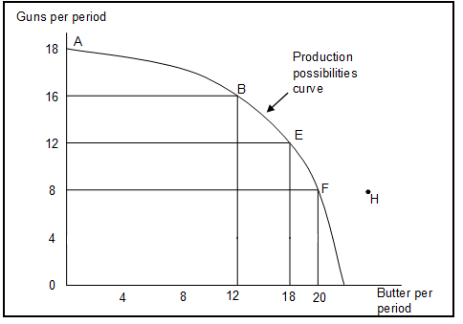

3. (LO 3) Refer to Exhibit 1. If the economy were operating at point B, producing 16 units of guns and 12 units of butter per period, a decision to move to point E and produce 18 units of butter:
 | a. | indicates you can have more butter and guns simultaneously.
 | b. | makes it clear that this economy experiences decreasing opportunity costs.
 | c. | involves an opportunity cost of 8 units of guns per period.
 | d. | involves an opportunity cost of 4 units of guns per period.
 | e. | involves an opportunity cost of 6 units of butter per period.

Exhibit 2: “Making Breakfast”
Sally can produce 50 pancakes or 20 muffins in a morning. Thomas can produce 30 pancakes or 10 muffins in a morning.
4. (LO 4) Refer to the Exhibit II Above. The opportunity cost for Sally to make one muffin is
a. 0.4 pancakes
b. 2.5 pancakes
c. 30 pancakes
d. 50 pancakes
e. 20 muffins

5. (LO 4) Refer to the Exhibit II Above. Following the law of comparative advantage, Sally should specialize in making ________ and Thomas should specialize in making _________.
a. | nothing; both pancakes and muffins
b. | both pancakes and muffins; nothing
c. | pancakes; muffins
d. | muffins; pancakes
6. (LO 5) The price of a slice of pizza in a local pizza parlor has recently decreased, ceteris paribus. What will occur?
- The quantity demanded of pizza will increase
- The quantity demanded of pizza will decrease
- The demand for pizza will increase
- The demand for pizza will decrease.

7. (LO 6) Spaghetti has recently increased in price. What will happen in the pasta sauce (a complement to spaghetti) market?
- Demand for pasta sauce increases
- Demand for pasta sauce decreases
- Supply of pasta sauce increases
- Supply of pasta sauce decreases

8. (LO 6) A frost in Northern California destroys many vineyards, which is used to produce wine. What will happen in the market for wine?
  - Demand for wine increases
  - Demand for wine decreases
  - Supply of wine increases
  - Supply of wine decreases

9. (LO 7) The processing power of computers has increased, making it easier for the firm A&B Block Tax Accountants to process tax returns. Ceteris paribus, what will happen to the price of accounting services and the number of accounting services delivered?
- Equilibrium price increases; equilibrium quantity increases
- Equilibrium price increases; equilibrium quantity decreases
- Equilibrium price decreases; equilibrium quantity increases
- Equilibrium price decreases; equilibrium quantity decreases

10. (LO 8) Refer to Exhibit 3. The Russian government recently put a price floor on the sale of vodka, changing its market price. Which of the following graphs most closely represents the new market for vodka in Russia?

- Graph A
- Graph B
- Graph C
- Graph D

Exhibit 3: Market Theory
Graph A: Graph B:

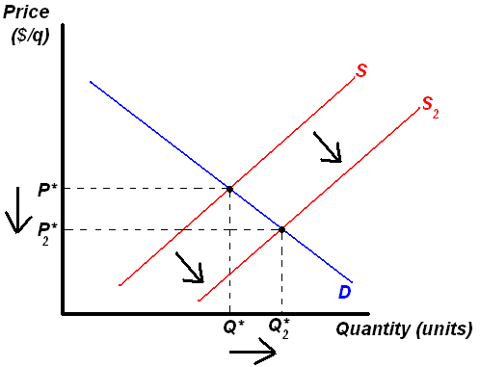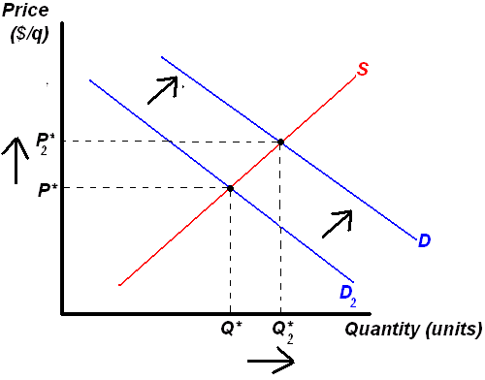

Graph C. Graph D
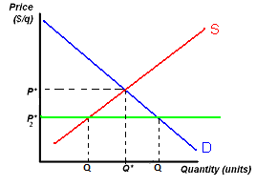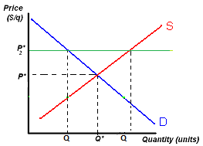

- (LO 8) The government increases the federal minimum wage to $10.00 an hour from the equilibrium wage of $7.25 per hour. Which of the followings is NOT a possible outcome of the government policy?
  - The number of workers seeking work will increase
  - The number of workers hired will increase
  - Employers will reduce the quantity of hours demanded for labor
  - The equilibrium wage rate will stay at $7.25 per hour

- (LO9) When the price of artichokes decrease by 20%, quantity demanded increases in 40%. What is the price elasticity of demand for artichokes?
  - 0.5
  - .67
  - 1.5
  - 2
  - 20

- (LO10) Which of the following changes would increase the price elasticity of demand of a good?
- The time period in which to shop for a car decreases.
- You have an increase in income at your work, decreasing the impact a purchase of a refrigerator would have on your household budget.
- New firms enter the market, offering new substitutes for MP3 players.
- Some stores in the Mall clothes, providing less options to purchase a pair of jeans.

- (LO11) The manager of Ahabs Coffee decides to reduce the price of medium cup of coffee from $4.00 to $3.00. Assume the price elasticity of demand for coffee is 2.7. Is the demand for Ahabs Coffee elastic or inelastic? What happens to the total revenue of the Ahabs Coffee?
  - Elastic; total revenue increases
  - Elastic; total revenue decreases
  - Inelastic; total revenue decreases
  - Inelastic; total revenue increases

- (LO12) – In order to maximize the net benefits of any activity, which condition must be satisfy?
- marginal benefits (MB) = marginal costs (MC)
- total benefits (TB) = total costs (TC)
- marginal benefits (MB) > marginal cost (MC)
- total benefits (TB) > total costs (TC)
- price (P) = average total cost (ATC)

- (LO13) Which description best describes the concept of consumer surplus?
- The difference between the highest price consumers would be willing to pay for a good and the actual market price that they end up paying for it.
- The difference between the actual market price of a good and the lowest price a seller is willing to sell to a consumer for.
- Consumer that already has a large supply of a goods are not willing to pay a high price for additional goods.
- Firms that overproduce a good will give steep discount to entice consumers to buy them.
  - The utility a consumer receives from the consumption of goods.

- (LO14) For the first three cookies consumed, marginal utility remained constant. By the third cookie, total utility was _____ after the 1st cookie consumed.
  - Lower than
  - the same as
  - higher than

- (LO15) As Betsy eats more peanut butter cookies in an afternoon, ceteris paribus, what will happen?
  - Her total utility will increase indefinitely
  - Her marginal utility will increase indefinitely
  - Her marginal utility will eventually fall
  - Her marginal utility will remain constant.

- (LO16) Kim purchases 6 cups of coffee and 4 cups of tea each week from the local café. Kim is currently in consumer equilibrium. Recently, the café raised its price of a cup of tea. As a result, the marginal utility per dollar spent on coffee is now _______ the marginal utility per dollar spent on tea. As a result, Kim will likely purchase more _______.
- greater than; coffee
- great than; tea
- less than; coffee
- less than; tea
- (LO17) A farm can produce 1,000 bushels of wheat per year with 2 workers and 1,200 bushels of wheat per year with 3 workers. The marginal product of the third worker is
- -100 bushels
- 200 bushels.
- 400 bushels.
- 1,200 bushels.
- 2,200 bushels.

- (LO18) As a result of the law of diminishing marginal returns, eventually, the marginal product of labor (MP_{L}) will _____, and marginal cost (MC) will ______.
- decrease; decrease
- decrease; increase
- increase; decrease
- Increase; increase

- (LO19) which one of these is a fixed cost?
- The electricity used to operate a factory.
- The aluminum used to make cars.
- The lease on the office building.
- The cost of wages for workers picking fruit.
- The gasoline used to transport goods

- (LO20) - If for the next unit of output produced, the marginal cost (MC) is below the average total cost (ATC), then ATC is
  - Rising
  - Falling
  - Remaining constant
  - Insufficient information

Exhibit III: The Firm’s Long-run Average Total Cost
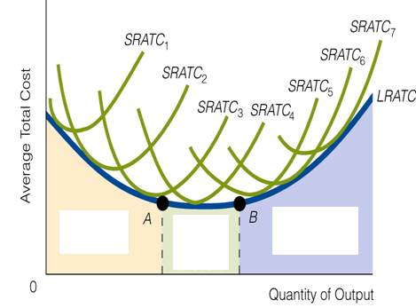

- (LO21) Refer to Exhibit III. Which part of the above graph shows “economies of scale”?
- To the left of A
- Between A and B
- To the right of B
- None of the above.

Exhibit IV: Price, Revenue, and Cost Data for A Firm

Quantity | 1 | 2 | 3 | 4 | 5 | 6 | 7
Price | $60 | $60 | $60 | $60 | $60 | $60 | $60
Marginal Revenue | $60 | $60 | $60 | $60 | $60 | $60 | $60
Marginal Cost | $20 | $10 | $20 | $30 | $40 | $55 | $70
Average Total Cost | $120 | $80 | $60 | $53 | $50 | $51 | $53

- (LO32) Refer to Exhibit IV. Which market structure is this firm operating in?
- Perfect competition
- Monopoly
- Monopolistic competition
- Oligopoly

- (LO23) Refer to Exhibit IV. According to the profit maximizing rule, what is the profit-maximizing level of output for this firm to produce?
- 2 units
- 3 units
- 5 units
- 6 units
- 7 units

- (LO23) Refer to Exhibit IV. What is the maximum profit this firm could earn?
- $28
- $30
- $49
- $50
- $54

- (LO24) If a firm is earning a positive economic profit, then the firm is definitely facing which of the following conditions?
- Price is greater than average total cost (P > ATC)
- Average total cost is greater than average variable costs (ATC > AVC)
- Total revenue is equal to total costs (TR = TC)
- Average fixed costs are greater than average variable costs (AFC > AVC)
- Marginal Revenue is greater than marginal costs (MR > MC)

- (LO25) Assume that the perfectly competitive market for corn is in long-run equilibrium, and the market price for corn increases. In the short-run, the demand for corn faced by the individual farmer will __________, and this will encourage the farmer to ________.
- shift down; produce less
- shift down; produce more
- shift up; produce less
- shift up; produce more

- (LO25) Assume perfectly competitive firms are making positive economic profit. What will happen at the market level during the transition to the long-run?
  - Demand increases
  - Demand decreases
  - Supply decreases
  - Supply increases

- (LO26) Which of the following is not a barrier for a firm to enter into an industry?
- Economies of scale
- Restricted ownership of inputs
- Patents
- Technological innovation
- Government licensing

- (LO27) Relative to a perfectly competitive industry, a monopoly produces _______ output and charges a _______ price.
  - less; lower
  - less; higher
  - more; lower
  - more; higher
- (LO28) “In order to do this, the firm must have some price setting ability, be able to distinguish between customers, and prevent resale”. What is being discussed?
- privatization.
- monopolization.
- Competitive markets.
- price discrimination.
- Cartel formation

- (LO29) A particular industry is made up of only 5 firms, each consisting of a 20% market share. What is the Herfindahl-Hirschman Index (HHI) for this industry?
- 4
- 100
- 400
- 1,200
- 2,000

- (LO30) The goal of a cartel is to _______ each members’ output, which will ________ prices and increase the cartel’s profit.
- decrease; decrease
- decrease; increase
- increase; increase
- increase; decrease

Exhibit V: Game Theory
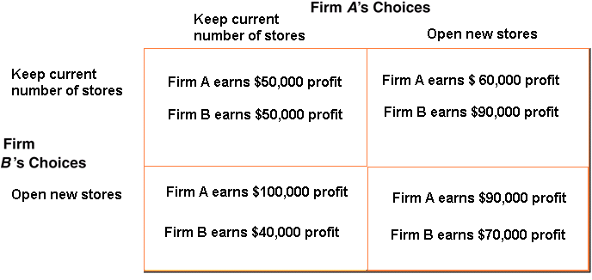

- (LO31) Firm A and Firm B are the only two hardware stores in town, and each are deciding whether to open a new store or keep their current number of stores (see Exhibit V). The profit they will earn from this decision depends on what the other firm does. Using game theory analysis, what will be the outcome to this situation (“Nash equilibrium”).
- Firm A keeps current number of stores; Firm B keeps current number of stores
- Firm A keeps current number of stores; Firm B opens new store
- Firm A opens new store; Firm B keeps current number of stores
- Firm A opens new store; Firm B opens new store

- (LO32) Which market structure includes the assumptions of many sellers, selling slightly differentiated goods, with low barriers to entry?
  - Perfect Competition
  - Monopoly
  - Monopolistic Competition
  - Oligopoly

- (LO32) Which market structure includes the assumptions of few sellers with significant barriers to entry?
  - Perfect Competition
  - Monopoly
  - Monopolistic Competition
  - Oligopoly
Exhibit VI: Demand Curves Faced by Firms Under Different Market Structures
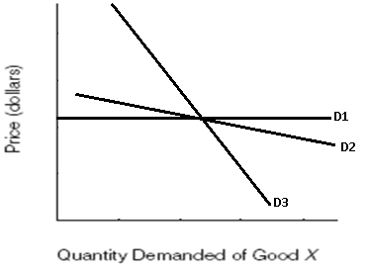

- (LO33) Refer to Exhibit VI. Match the demand curve to the appropriate market structure.
- D1 = Perfect Competition, D2 = Monopolistic Competition, D3 = Monopoly
- D1 = Perfect Competition, D2 = Monopoly, D3 = Monopolistic Competition
- D1 = Monopolistic Competition, D2 = Perfect Competition, D3 = Monopoly
- D1 = Monopolistic Competition, D2 = Monopoly, D3 = Perfect Competition
- D1 = Monopoly, D2 = Perfect Competition, D3 = Monopolistic Competition,

- (LO34) Which is marginal revenue product of labor (MRP_{L}) equal to?
  - Marginal Revenue (TR) * total output (q)
  - Price (p) * total output (q)
  - Marginal Product of Labor (MP_{L}) * Marginal Revenue (MR)
  - Total revenue – total cost
  - Marginal Revenue * Marginal Cost

- (LO35) Which of the following will increase the demand for labor?
- An increase in wage rates
- The price of a complimentary factor increases
- The opportunity cost of working decreases
- Workers become more productive
- Income taxes on hours worked decreases

- (LO36) What is the present value of $1,000 gift that one will receive two years from now, at an annual interest rate of 10%?
- $786.58
- $826.44
- $980.30
- $1,200.00
- $1,210.10

43. (LO37) Which of the following would decrease equilibrium interest rates in the loanable funds market?
a. Capital becomes more productive
b. Households begin to save more of their income
c. Business expectations become more optimistic
d. The demand for automobiles by consumers increases
Exhibit VII: The Monopsony Employer
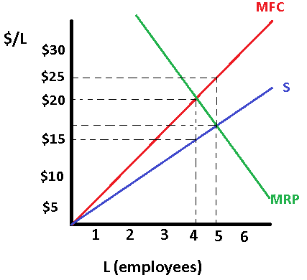

44. (LO38) Refer to Exhibit VII. The profit maximizing level of employees to hire is approximately ________ and to pay them a wage rate of about _______.
- 4; $15
- 4; $20
- 5; $17
- 4; $25

45. (LO39) Which of the following is the best example of an antitrust law?
  - The government requires automakers to install seatbelts in all new cars.
  - The United States Postal Service is the only organization legally allowed to deliver mail.
  - It is illegal for a person to sit on the board of directors of two competing firms simultaneously.
  - It is illegal for firms to dump toxic waste into rivers or lakes.
  - A firm could not discriminate against a potential employee because of their race, ethnicity, or sex.

46. (LO40) how do economist measure income inequality in a country?
- Calculate the percentage of families living below the poverty line.
- Calculate the gini coefficient, using the Lorenz curve.
- Survey households on their opinion of income inequality.
- Take the highest earning income earners, subtract the lowest earning income earners, and divide by two.
- Compare the mean (average) income earner today, relative to the average in past years.

47. (LO41) Which statement below best describes the change in income distribution between the 1960s and today?
- The income distribution has actually been quite stable
- The lower 20% of households have received a higher share of income
- The middle 20%of households have received a higher share of income
- The top 20% of households have received a higher share of income
- All households have received a higher percentage of total income

