**Section 1.3 - Direction Fields (graphing ODE)**

**Goal:** Visualize a differential equation and its solution.

**Fact**: In most real world cases, it is NOT possible to find a solution to an ODE.

**Try:** Approximate the solution using direction fields (we will be graphing the differential equation and using it to approximate what the original equation is doing). I.E. We will be graphing a bunch of tangent lines (the derivative represents the slope of the tangent line)

Ex1) In your groups, draw tangent lines on the on each graph at x = -3, -2, -1, 0, 1, 2, 3:

A. B.

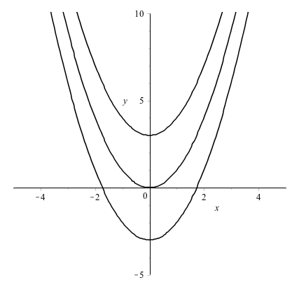 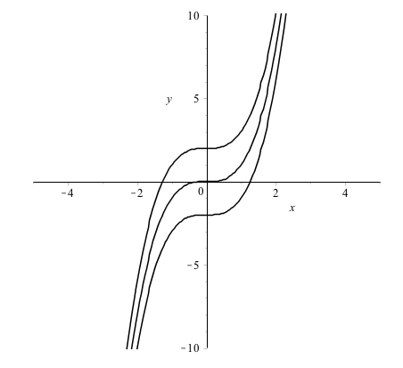

C. plot tangent lines at x = -5, -4, -3, -2, -1, 0, 1, 2, 3, 4, 5

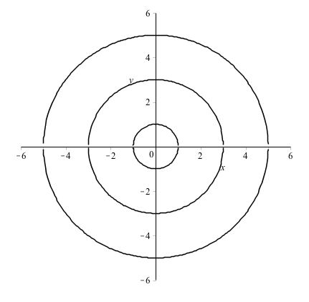

Ex2). At your tables, find the value of dy/dx = -x/y for the given table numbers. Plot the tangent line on the board.

Table 1: (-4, y) Table 2: (-3, y) Table 3: (-2, y)

Table 4: (-1, y) Table 5: (1, y) Table 6: (2, y)

Table 7: (3, y) Table 8: (4, y)

Mrs. B: (0,y)

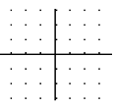

Based off of your graph above, what do you think is the solution to the ODE?

A slope field (direction field) shows the general “flow” of a differential equation’s solution. They can be used to approximate solutions.

Ok – now let’s suppose we give you a direction field (i.e. graph of a bunch of tangent lines that represent the family of functions that solve a differential equation). Answer the following based off of the given direction field.

Suppose you were in a science class, and you were given the following direction field where the independent variable is time and the dependent variable is the temperature (in Celsius) of some liquid that is held in a glass jar. Based off of the given direction field, answer the following questions on a ***separate sheet of paper***.

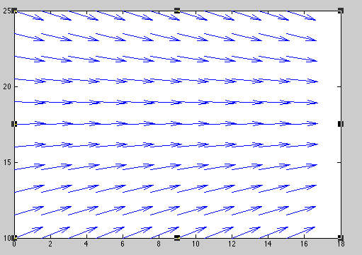

A. If the temperature of the liquid is 13 degrees Celsius, what would be the terminal temperature? (I.E. what would be the temperature if you left the liquid in the room for a very long time). EXPLAIN your reasoning for your answer.

B. Sketch the solution to the ODE that has an initial temperature of 13 degrees Celsius on the graph above (clearly label your graph). EXPLAIN your reasoning for your answer.

C. If the temperature of the liquid is 25 degrees Celsius, what would be the terminal temperature? Draw the solution to the ODE that has an initial temp of 25 degrees Celsius on the graph above (clearly label your graph). EXPLAIN your reasoning for your answer.

When you are done, turn in this page along with your work from the separate sheet of paper. 5pts hwk

Ex 3) Let f(t,y)=dy/dt = sint then what is y?

Below is the graph of dy/dt. Does the slope field match your solution to y?

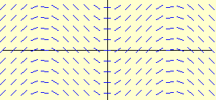

At your tables, draw a slope field (direction field) for the following differential equations. Answer the given questions that following your slope field.

4. 



A. If y(1) = -1, draw the solution curve. Estimate y(0) based off of your solution curve.

5. 



A. If y(0)=-2, draw your solution curve. Estimate y(1) based off of your solution curve.

More Examples:

dy/dx = x dy/dx = y

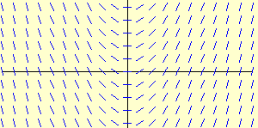 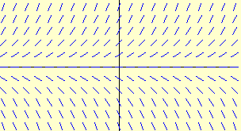

If y(-2) = 1, draw the solution curves for both ODE above.

Estimate y(0) based off of your curve.

6. The slope field from a certain differential equation is shown above. Which of the following could be a specific solution to that differential equation?

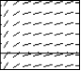

(A)  (B)  (C)  (D)  (E) 

7. The slope field for a certain differential equation is shown above. Which of the following could be a specific solution to that differential equation?

Macintosh HD:Users:rebeccabaranowski:Desktop:Screen Shot 2015-01-04 at 7.38.53 PM.png

(A)  (B)  (C)  (D)  (E) 

Now, let’s use MATLAB to graph direction fields.

1st: Open MATLAB and click on “New” in top left hand corner. Screen Shot 2014-08-21 at 2 Then click on “script”.

A new window should open up that says “Editor-untitled”. Here is where you will create an “mfile”. You will be able to save this file and use it on exams.

2nd: Type in the following into the script (Note: You can choose any notes to insert after the % symbol).

%This matlab file will draw direction fields for the provided DE

%Save file: dirfields.m

%To run and see other DE, then change the dY equation

t=-3:1:5; y=10:1:25; %Edit viewing window here

[T,Y]=meshgrid(t,y);

dT=ones(size(T));

dY=-0.055*Y+1; %Insert ODE here - be careful with .* vs * only

N=sqrt(dT.^2+dY.^2);

dT=dT./N;

dY=dY./N;

axis equal; axis ([-4 4 -4 4]); grid on;

quiver(T,Y,dT,dY)

3rd: Click on the “Run” arrow: Screen Shot 2014-08-21 at 2

4th: A window will pop up to ask you to save this. Choose a name for your program (I chose “dirfields”) Keep the “where” location as MATLAB. Next time you open MATLAB, this should be there for you to use on the next exam. (you can also save on your jump drive).

5th: Once the program is saved, you should see the direction field. =)

Click the run button, and you should see a direction field for

dy/dt = =-0.055*Y+1

Note: You can write your own direction field script and save it. There are much better ones than the one on the previous page.

Be careful! If you have multiplication of variables (or division), you must use .* or ./

Also – this code requires the use of capital letters for your ODE to run (T and Y).

You can insert notes like this into your script and save it.

8. Match the slope fields with their differential equations.

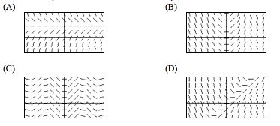

I.  II.  III.  IV. 

____________________________________________________________________________

9. Match the slope fields with their differential equations.

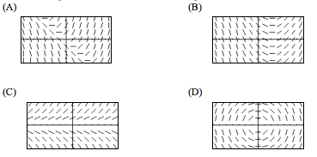

I.  II.  III.  IV. 

10. (a) On the slope field for , sketch three

solution curves showing different types of behavior

for the population *P*.

(b) Is there a stable value of the population? If so, what is it?

(c) Describe the meaning of the shape of the solution curves

for the population: Where is *P* increasing? Decreasing?

What happens in the long run? Are there any inflection

points? Where? What do they mean for the population?

(d) Sketch a graph of  against *P*. Where is  positive?

Negative? Zero? Maximum? How do your observations

about  explain the shapes of your solution curves?

For each situation in 11 and 12,

1. Write a differential equation from the given information and answer the given question.

(b) Use MATLAB to sketch a slope field for the DE. Use the slope field to determine the long-term pattern. Include the solution curve on your direction field.

11. Little Red Riding Hood loses 20% of her muffins to the Big Bad Wolf on every mile of her walk to Grandma’s house. The Muffin Man supplies her with 3 more every mile (he’s sort of a stalker). How many muffins will Red Riding Hood eventually have for her Grandma if she starts with 6 muffins?

12. Goldilocks eats 75% of the Bears porridge every time she visits, but Mama Bear adds 5 oz of porridge to the pot after each visit. If Mama Bear started with a 16 oz porridge pot, how much porridge will Mama Bear eventually have?

13. Given the following direction field, answer the provided questions/statement.

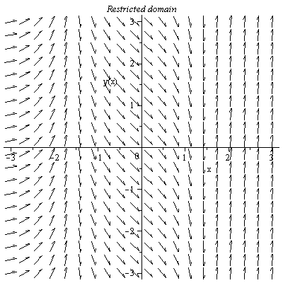

A. Explain what the direction field represents.

B. Give at least 3 characteristics that the original equation may have.

C. If y(-3) = -2 is the initial value, what happens to y as x increases in value?

D. For what values of x does the original function increase most rapidly? Please explain.

Practice: 1.3 (pg. 21) #1-5, 7