Inspired by Proust: A Multi-Sensory Approach to Memorizing Principle Verb Parts in ESL
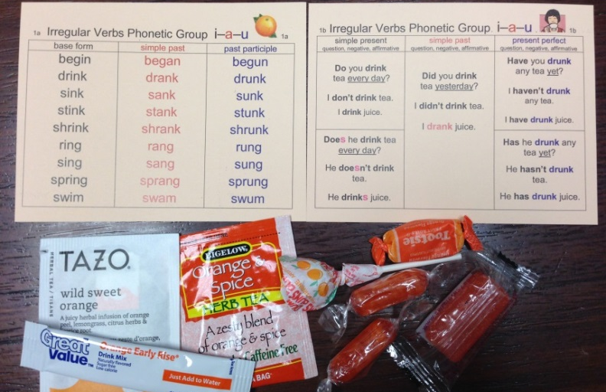

Learning any second language requires memorization of vocabulary and word forms. In my ESL030 Grammar III class, students need to memorize the 3 principle parts of English irregular verbs (simple, simple past, and past participle forms, as in eat-ate-eaten). Knowledge of the past participle form is particularly important when we study the present perfect verb tense (e.g. I have seen, he has gone). Students frequently struggle to memorize the seemingly random and numerous changes that occur. While many verbs are unique, there are many verbs that follow certain phonetic patterns, such as drink drank drunk & ring rang rung, or grow grew grown & know knew known. Still, this memorization task is a challenge.

The question for a language teacher is often, “How do I help students acquire this vocabulary? How do I make it memorable? I myself vividly remember reading French philospher/writer Marcel Proust’s story of how the scent of a freshly-baked madeleine cookie instantly triggered memories of his childhood. Drawing inspiration from Proust and his discussion of involuntary memories (automatic recall) and physical stimuli (e.g. smell), I decided to make a set of 10 study cards to give to students. Each card had a group of verbs which followed a similar phonetic pattern. The front side of the card lists the verbs and the back side shows how the different parts are used in the simple present, simple past, and present perfect tenses. I chose a different cardstock color to print each card on and different scent/flavor to associate each card with. Essential oils were swiped across the top and bottom of each card (unscented cards were available for those with allergies). I tried to make choices connected to the phonetic sound or meaning of a verb in the group. For example, verbs that followed the rhyme pattern teach taught taught & buy bought bought were grouped on a brown card scented with chocolate and distributed in a bag with chocolate candy and hot chocolate drink mix; verbs with the pattern bite bit bitten & hide hid hidden were grouped on a red card scented with cinnamon and distributed in a bag with cinnamon gum & tea. Videos including pronunciation of the verb parts set to music were also made.

I gave students 1-2 study cards each class, we listened to the videos and went over the pronunciation, and then students were told to go home and drink the flavored teas/water mixes and eat the candy (sugar-free varieties were available for diabetics) while studying.

Improvements in test scores on the present perfect (the chapter studied in the weeks the cards are distributed) since the introduction of this "multi-sensory study strategy" have improved in the last two semesters compared to previous semesters in which I did not give these cards to students: 93.8% and 87.4% this 2014-2015 academic year compared to 81.6, 79.5, 77.4, 84.5, and 83.3 for Fall 2012 – Spring 2014 semesters. Comments on course evaluations by students indicate the technique is quite memorable and they feel it is helpful. Many students continue to carry the cards with them after the semester/course is finished and use them in the next level. When I give them study cards for other grammatical topics, they expectantly hold them up to their noses and then express dismay to find no scent. The strategy has not worked miracles, but the majority of students have enjoyed it.

Diane Stonebrink Spring 2015

