Sample of Single Point Rubric from course
The current rubric structure in Canvas does not allow for the typical Single-Point Rubric layout, but does allow for the similar idea to be used.

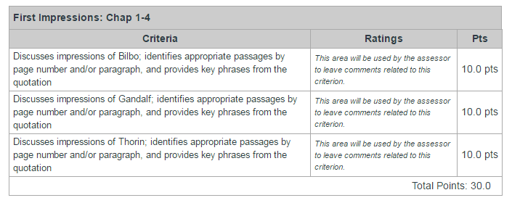

Single-Point Rubric typical layout:
Advanced:  Evidence of Exceeding Standards | Criteria:  Proficiency Standards for this Assignment | Concerns:  Areas that Need Work
 | Discusses impressions of Bilbo; identifies appropriate passages by page number and/or paragraph, and provides key phrases from the quotation
 | Discusses impressions of Gandalf; identifies appropriate passages by page number and/or paragraph, and provides key phrases from the quotation
 | Discusses impressions of Thorin; identifies appropriate passages by page number and/or paragraph, and provides key phrases from the quotation

