I want to go green, but will it bring down my mean? Examining differences in mean scores using paper vs. electronic quizzes in statistics courses

Is there really a need to kill another tree if Canvas provides a medium for quizzes? In a quasi-experimental design, introductory statistics students across two semesters with two different instructors (Spring and Fall ‘16) self-reported the number of hours spent studying for a common cumulative quiz based on previous weekly quizzes with one group using e-quizzes and the second group using paper quizzes. Results are as follows:

- Marginally significant differences in the number of hours spent studying using the quizzes with e-quizzers reporting slightly more time (M=3.76 hours, SD=4.88) than paper quizzers (M=2.71, SD=2.83), t(158)=1.72, p<.09;

- E-quizzers had significantly higher final grades (M=84%) than paper quizzers (M=79%), t(158)=2.35, p<.05;

- Significant moderate, positive correlation between number of hours spent studying for the quiz using weekly quizzes and the cumulative exam (r=.266, N=160, p<.01), even after controlling for instructor effect (r=.205, p<.01);

- No significant changes in self-reported number of hours spent studying from Spring ’16 to Fall ’16.

Recommendation: GO GREEN and the mean may rise to the occasion!

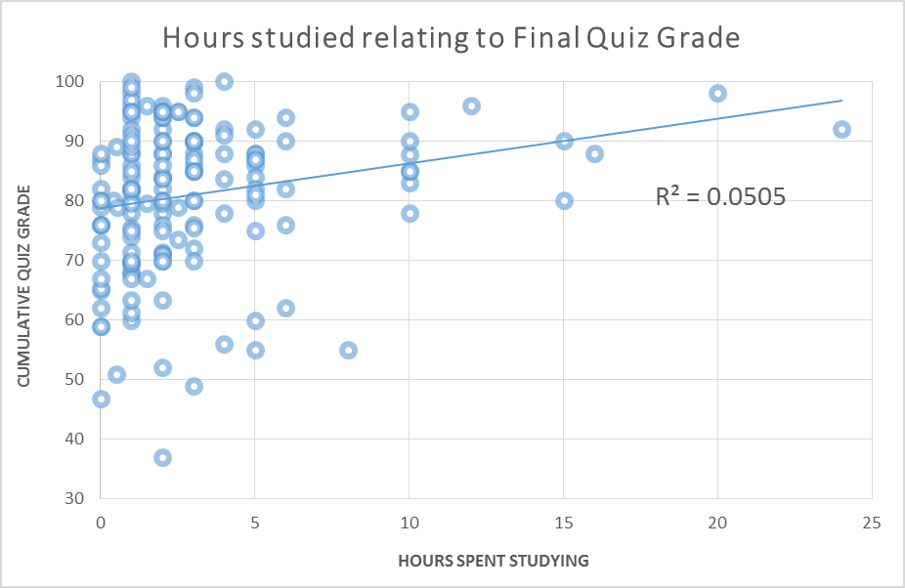

Collaborators: Erica Wager, M.A. and Norma Hernandez, Ed.D.

