Excavation Journal
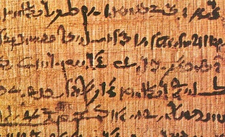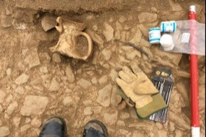
Welcome Archaeologists!
Throughout the course, you’ll be keeping an excavation journal as a record of your personal exploration of world mythology as a historical archaeologist.
Your task is to use your excavation journal to record:

- Observations
- Notes
- Questions
- Ideas
- Images
- Sketches
- Maps
- Artifacts

in addition to responding to guided questions that reflect ideas and concepts from our assigned textbook, additional class readings, films, and discussions.
Excavation Tools
For eight (8) class meetings you’ll use a Dig Sheet to complete your excavation journal. Each Dig Sheet will provide you with:
- assigned readings for that class session (including individual and group readings)
- the required Guided Questions to respond to in your journal
- a chart of artifacts to be collected for each level

Evaluation of Your Excavation Journal
You will determine the points/grade you earn for each Dig Sheet based on what level you complete:
- Field Director or A level
- Crew Chief or B level
- Shovelbum or C level

For eight (8) class sessions you’ll use the prescribed Dig Sheet to guide your work in your journal. As an example, for Dig Sheet 1: Greek & Roman you could complete Field Director level and earn 75 points and for Dig Sheet 2: Middle East you could complete Shovelbum level and earn 25 points. Your grade for the excavation journal will be entirely up to you.

A Field Director (75 points each/total possible 600 points)

B Crew Chief (60 points each/total possible 480 points)

C Shovelbum (53 points each/total possible 424 points)

Dig Sheets are listed under Syllabus on the left side menu of Canvas.

