The link is: https://forms.gle/2rNXNX5S4MHtT28u7

I have a total of 92 students between my three classes. I had 64% response rate to my survey that was given September 11-18, week 4 of Classes.

I sent out a survey to my MAT 151 because I wanted to know how many students are doing with what I have done with the format of class 3 weeks into the semester. I’m learning every day what I can try out, what is working and not working. I am also curious to see who is sitting in the classroom as far as their background. I asked that the survey be completed by September 18, 2020.

I have been teaching this class through Zoom. I have been using the Breakout rooms to have them work in groups of 4-5 students. I use the polling feature as a warm up for what was done last class. I use the chat feature for students to type in their responses to questions or calculations. I tell them not to hit enter until I make a count down for them to all submit at once. I also use chat for answering questions if they post them or when they ask me to not move on until they have all the notes I wrote on whiteboard.
These are the questions asked on survey:
- Pick your Section
- Is this your first year as a college student?
- Is this class your only Live Online class?
- Given the format of the class, do you think there is enough interaction between you and your teacher?
- Given the format of the class, do you think there is enough interaction between you and your classmates?
- How helpful are the breakout rooms, the chat feature, and polls done in class for your learning?
- What do you think is going well about class? This includes inside and outside of class.
- What do you think could improve about class? This includes inside and outside of class.
- Other comments or concerns about class you want to mention... the good, the bad, and the ugly.
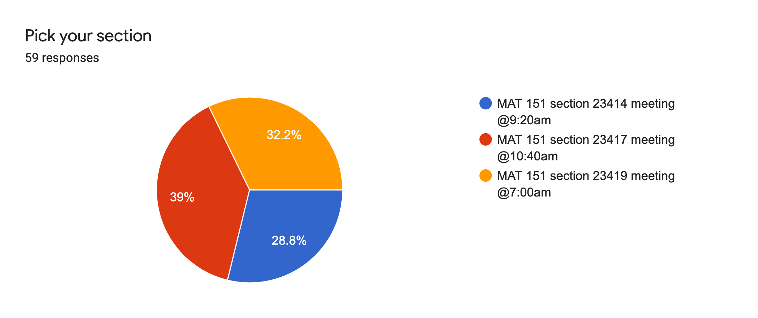

17 students from 9:20am
23 students from 10:40am
19 students from 7am
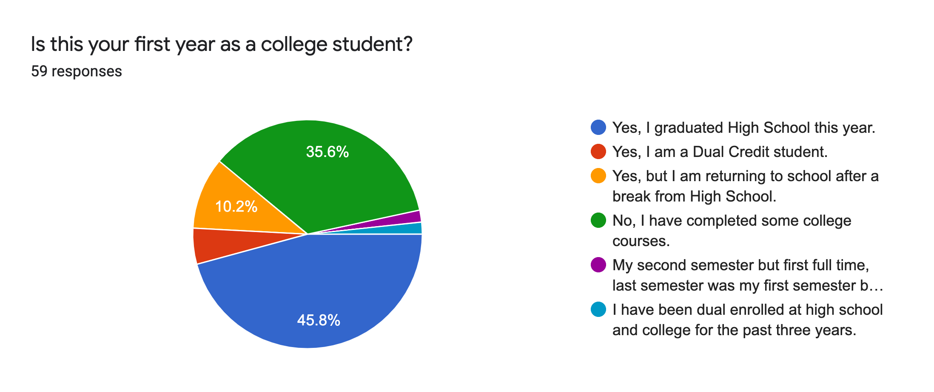
36 are first time college students of some form
23 have some college classes previously
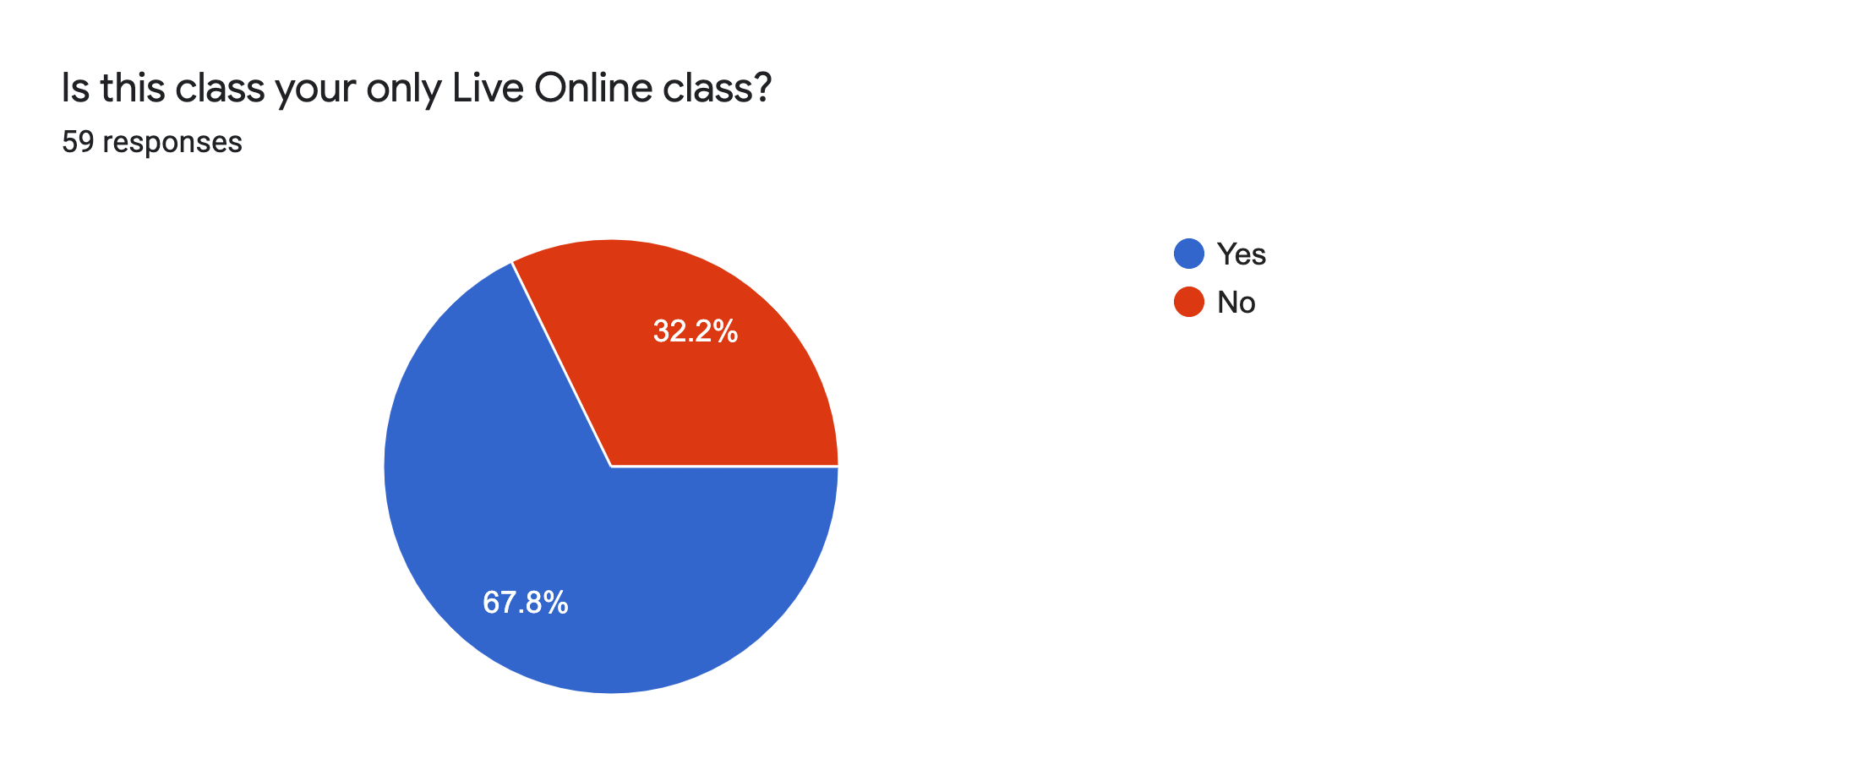
40 students have live online as their only class this semester. This is not very surprising since most other departments went traditional online for classes. In addition to that, 6 students have asked me to be their Honors mentor. The reason they asked me is that I’m the only teacher they have any interaction with because their other classes are traditional online.

Some interesting antidotes are:
-the recent High School students are struggling with not having peers or myself for personal at the moment interactions. When I have spoken to some of them about how things are going during my tutoring times, they mentioned how they are used to going up to the teacher during and after class to ask questions. What I have done to address this is to include in all of my emails and texts to them, is that I am here for them and they need to learn to be an advocate for their education.
-most have said that even though this is not a face to face class, the fact that they can ask at the moment makes a difference.
-one mentioned they are more likely to ask a question in this environment because I’m not calling on people but asking to share their thoughts in chat or out loud. They don’t feel as pressured or embarrassed.

