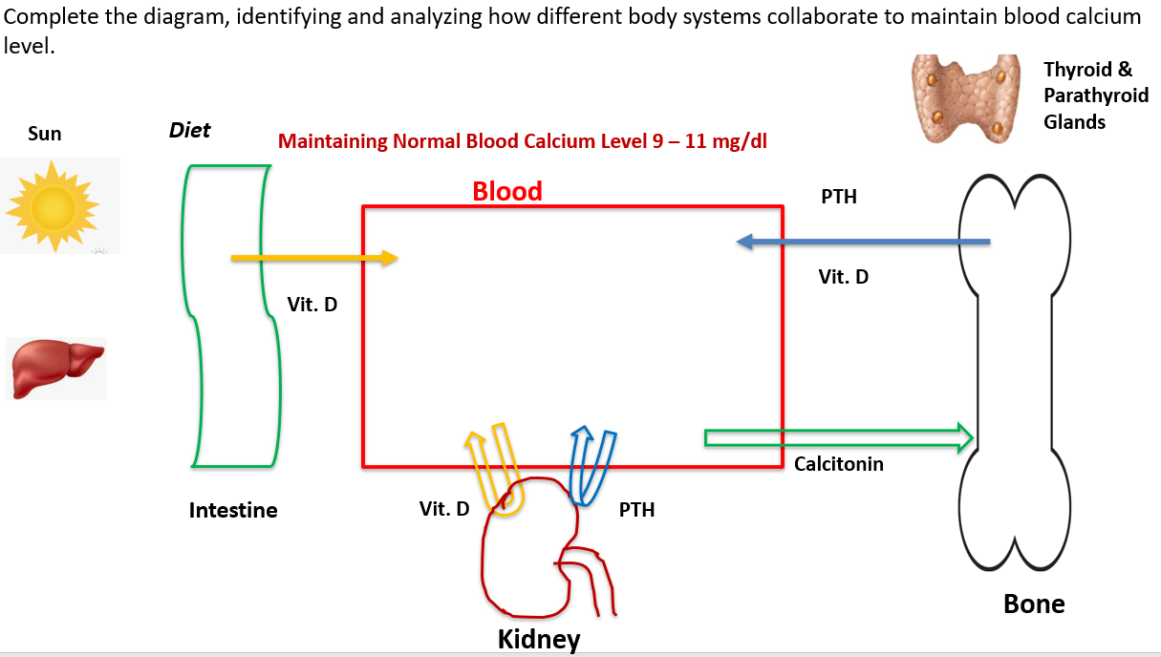

After completing the above poster, the students answer the following questions.
1. Identify (name) how many body systems are involved in maintaining blood calcium levels in the normal homeostatic range?

2. Explain the collaboration among different organ systems in response to Hypocalcemia (blood calcium becomes less than normal.

3. Explain the collaboration among different organ systems in response to Hypercalcemia (blood calcium becomes high than normal.

Practice quiz results:
Before developing the poster After developing the poster
6 | 6.5
7 | 9.5
6.5 | 9
8 | 9.5
5.5 | 7
6 | 7.25
4 | 6.5
5.25 | 8
5 | 9
7.5 | 10
4.5 | 6
5 | 7
4.25 | 5.25
6.5 | 6.5
5 | 7.5
7.5 | 10

Average score 5.6 Average score 7.9

The average score after developing the poster showed improvement.

