Weiru Chang
Estrella Mountain Community College
Avondale, Arizona

Learning Journals

I teach Anatomy and Physiology, a content heavy course that requires problem solving and critical thinking. Studying the material after each class and coming to class prepared is crucial to the students’ success. I have tried various methods such as quizzing and homework, but I found that these did not focus the students on the class material at the level I wanted and I was buried in mountains of grading. My solution to this problem was to implement the use of learning journals. Learning journals have been used for a number of years by the physics faculty at our school and more recently the chemistry faculty have adopted them as well. Last year, I used them for the first time with great success.

The content or style of the learning journals is up to the instructor. I used the journal as a way for students to summarize their notes, review concepts, and raise questions. The journals are organized with a table of contents and an entry must be made for every lecture and lab. The journals are collected at random times during the semester and students must bring their journals to class everyday. Comparing to semesters without learning journals, I find that the journals allow me to accomplish the following:
1. Better prepare students without adding additional assignments and quizzes
2. Daily use of journals became habit-forming for the students and improved their
journaling and study skills.
3. Grading was done at random 6 times throughout the semester. It was a way
to have a daily assignment without the daily grading.

As the semester progressed, I observed more and more the students using their journal to review for quizzes and exams. Students have a sense of pride in what they have accomplished in their journals and dedicate their journals to themselves, their family, and their dreams. The journaling is a significant amount of work. Most students filled over 100 pages. A number of students told me that they will use a learning journal for other classes whether it is required or not.

Data from class evaluation using Student Assessment of Learner Gain (SALG) salgsite.org:
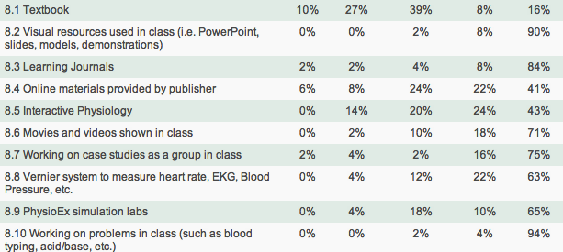 | Student Comments on the Learning Journal  “The learning journal helped me out a lot because it forced me to review the material and remember it more. ”  “Learning journals were hard to keep up with some times, but without it, I would not have studied as much.”  “I must comment on the journals. They helped me to study. It is a lot of information and having to rewrite it in a journal helps to go over the information again.”  “The learning journals were great and helped me rethink what I learned and better understand and study.”  “Learning journals were a big help because It helped the student write the notes in a way that we understand it and everything else helped as well.”

Analyzing the data:

I performed a survey at the end of the semester to ask how each aspect of the course helped their learning. The survey was done on salgsite.org. Among the ten things surveyed, the learning journal was ranked number three after working on problems in class and the presentation in class. The learning journal was ranked as the most useful item that they do outside of class. The students made comments that it made them study and review material on a daily basis. I have also received feedback from students who have taken courses after my class. Students remarked that the journal really helped them in Pathophysiology and nursing courses. I have continued with the journal as a integral part of the course and will add data each semester.

