Siggard Anderson Normogram

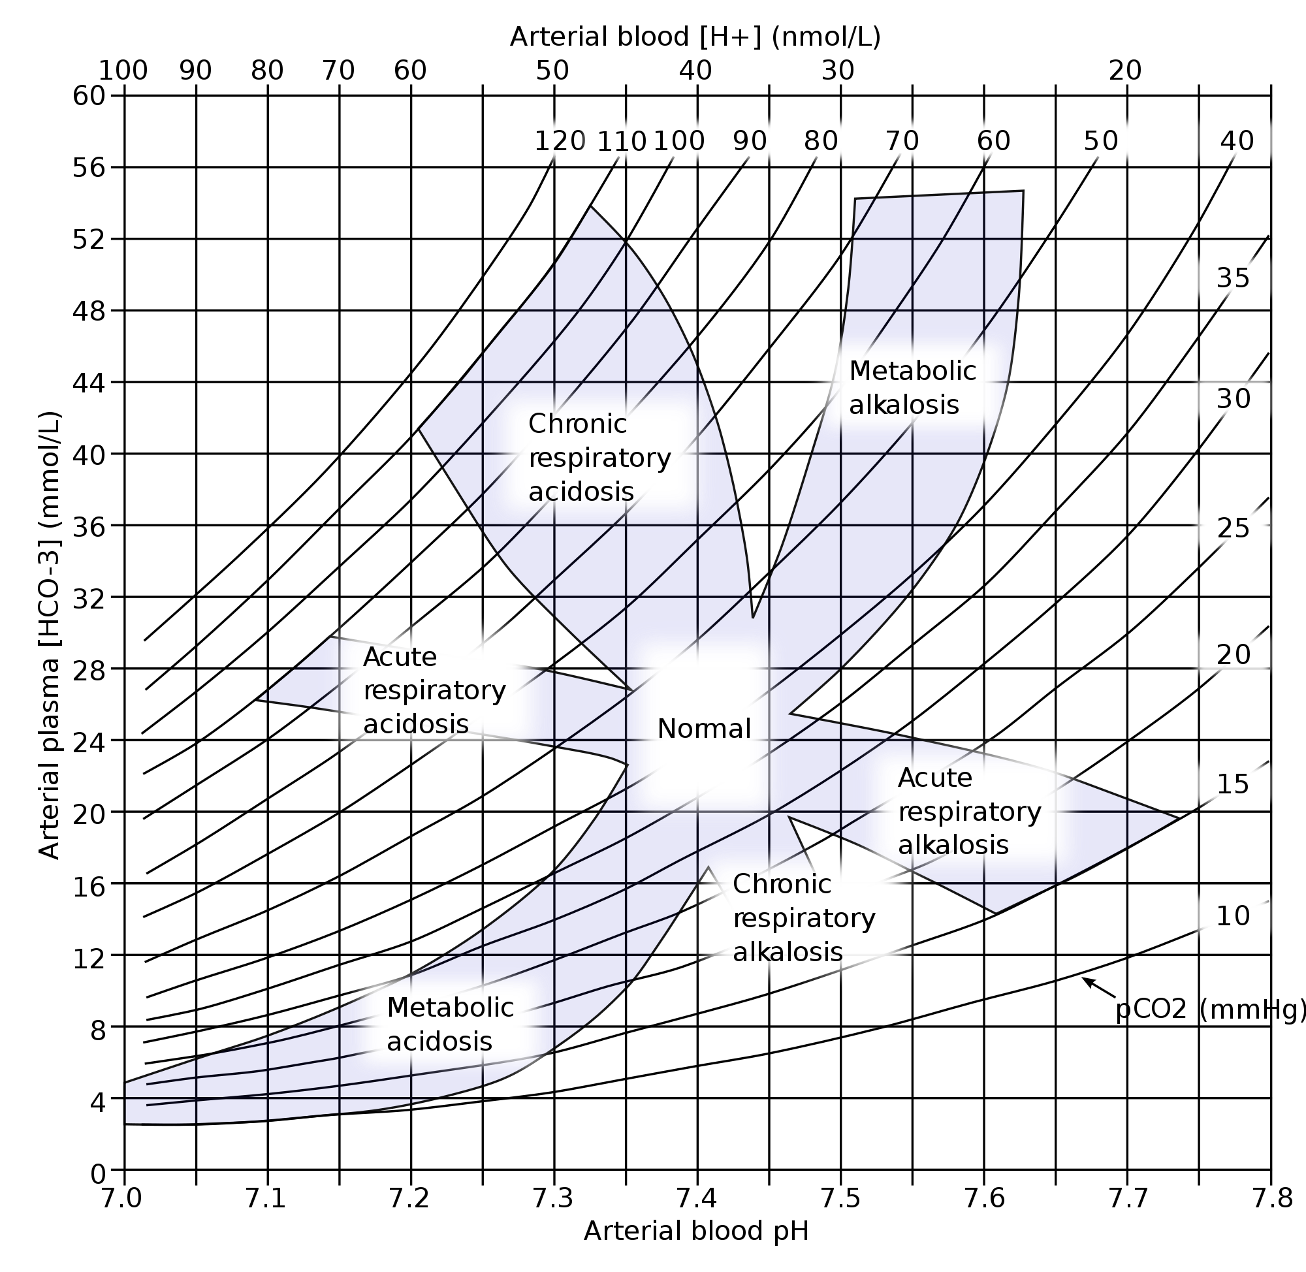

Q. Fifty year old J K is a type I diabetic. He manages his blood glucose with Insulin injections. He has been suffering from viral diarrhea for the last two days, he complains of loss of appetite, during this illness he has neglected to take his insulin shots. His condition is deteriorating and now he also complains of nausea and vomiting to his daughter, who drove him to the hospital, the admitting nurse noted fast and shallow breathing with an abnormal fruity odor in his breath. The Arterial blood Gases result of the patient are: pH = 7.28 HCO₃ = 16 CO₂ ₌ 30

Normal values are: pH = 7.35 –7.45 HCO₃ = 22 -26 CO₂ ₌ 35 - 45

a. Determine the main problem of the patient --------------------------------------

b. What type of compensation has occurred, if any? ----------------------------------
REFERENCES
1. Scientific style and format: the CBE manual for authors, editors, and
publishers, 6th ed. Style Manual Committee, Council of Biology
Editors. New York: Cambridge University Press, 1994.
2. Iverson C, Flanagin A, Fontanarosa PB, et al. American Medical
Association manual of style: a guide for authors and editors, 9th ed.
Hagerstown, Maryland: Lippincott Williams & Wilkins; 1997.

