Spring 2016
MAT220 – 5 credit class
69 students
7 sections

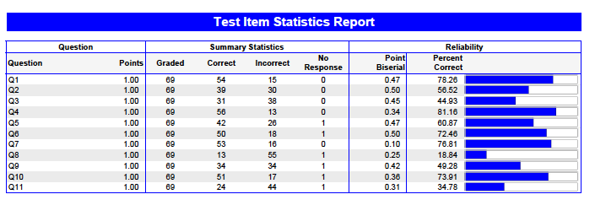

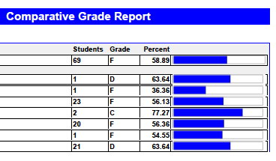

Spring 2016
MAT221 – 4 credit class
Calculus/Physics Learning Community
16 students
1 section

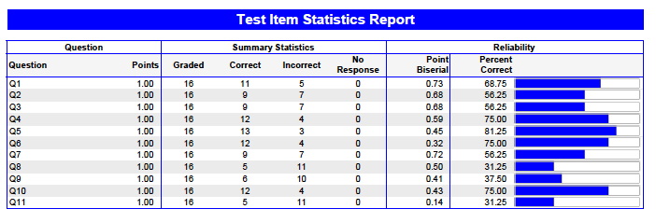

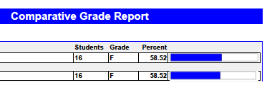

Summary – The multiple-choice questions are written in a way so that faculty can determine the mistakes made by students (common errors). Faculty will continue to work on improving teaching techniques so that these common errors do not occur. Also, the faculty will continue to have students show work on separate sheets of paper.

Fall 2016
MAT220 – 5 credit class
110 students
6 sections

Full and part time faculty met during the week of accountability in Fall 16 to discuss the common final questions. Modifications were made to the spring common questions. Questions 1-5, 7-11, and 14 remained the same with other questions modified. The new common final was given in December 16.

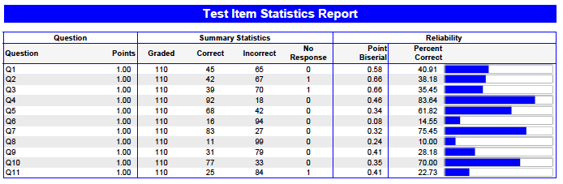
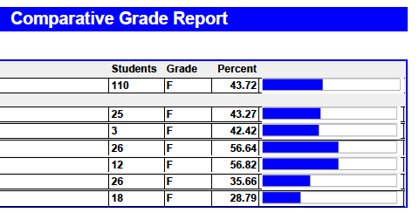

Summary –The fall semester results were much worse than the spring semester data. Please note that we do NOT teach to the test. From discussion with one instructor who had three of the 6 sections, a majority of the mistakes made were small. The scratch work showed that students had the right idea.

The class with 2 students was an honor’s section. The 3 classes with 1 student listed section numbers that do not exist. It is the belief of the calculus faculty that the students wrote in the wrong section number.

