Spring 2016
MAT081 – 4 credit class
277 students
12 sections
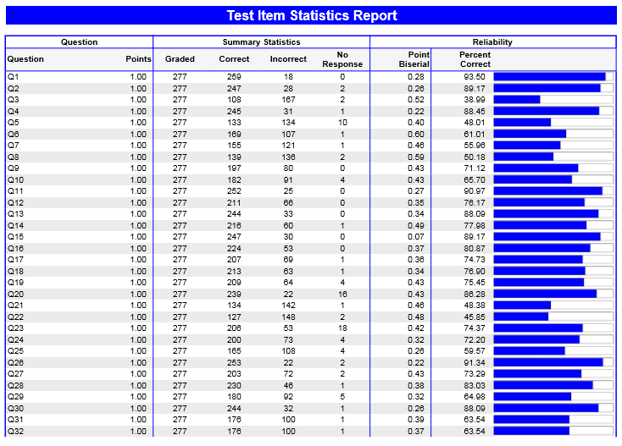
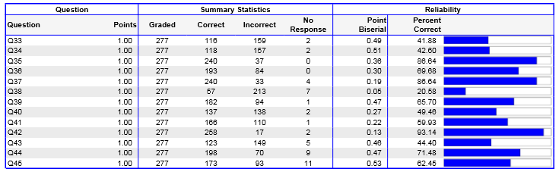

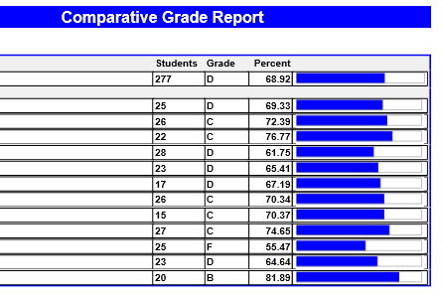
Summary:
Number 38 has the lowest correct score at 20.58% of students getting it correct. This question uses large (in the hundreds of thousands) numbers to find a percentage and it is consistently the most often missed problem. It is normal for students at this level to be uncomfortable with numbers these large, but as instructors we can help by incorporating large numbers more often. The second lowest correct score is number 3 at 38.99% correct. This question asks students to multiply two mixed numbers, without a calculator.

Fall 2016
MAT081 – 4 credit class
432 students
18 sections

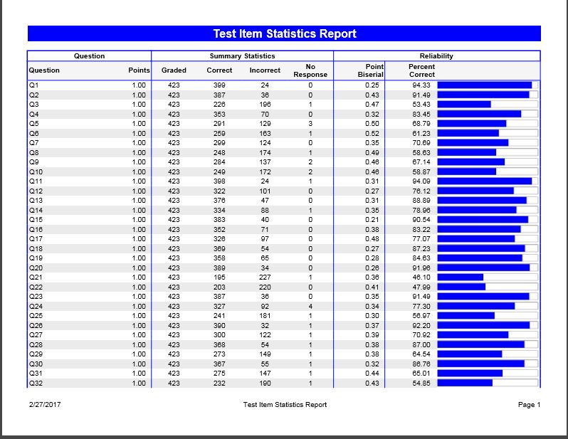

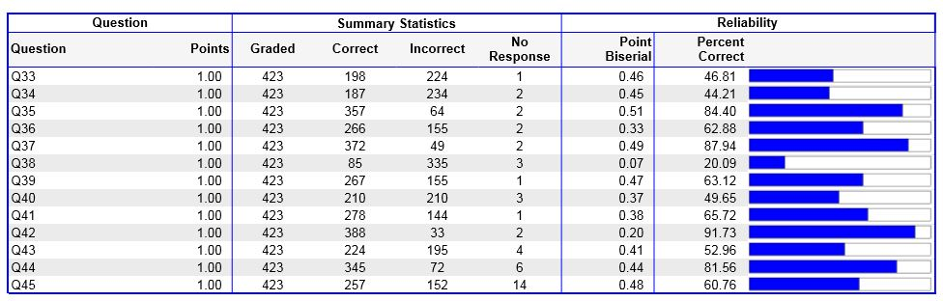
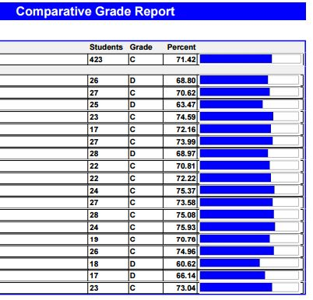

Summary:
There was a slight increase in the overall percent from Spring 2016 (68.92%) to Fall 2016 (71.42%). Number 38 was again the lowest scoring problem. However, the second lowest score in Spring 2016 was #3 at 38.99% and in Fall 2106 it was 53.43%.

