Spring 2016
MAT091 – 4 credit class
388 students
20 sections

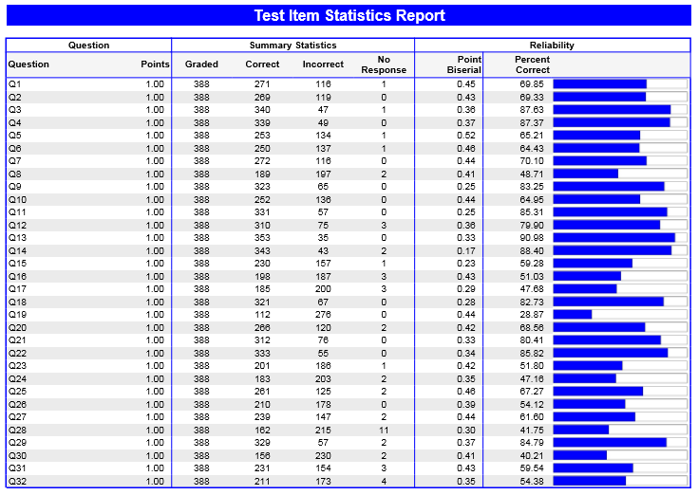

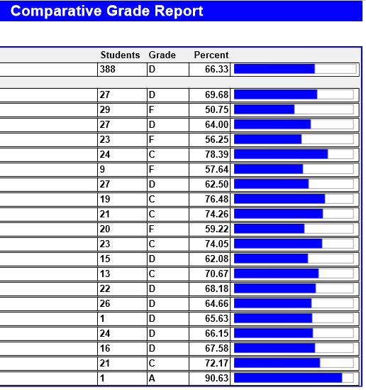
Summary:
The problem with the lowest percent correct is #28 at 28.87%. This problem consists of students subtracting a trinomial from a binomial, written out in words, not already set up. This is a common error since it isn’t intuitive on how to set it up (which polynomial should come ‘first’) as well as having to distribute a negative which again is a difficult concept and can be easily overlooked even if the problem is set up correctly.

Fall 2016
MAT091 – 4 credit class
379 students
20 sections

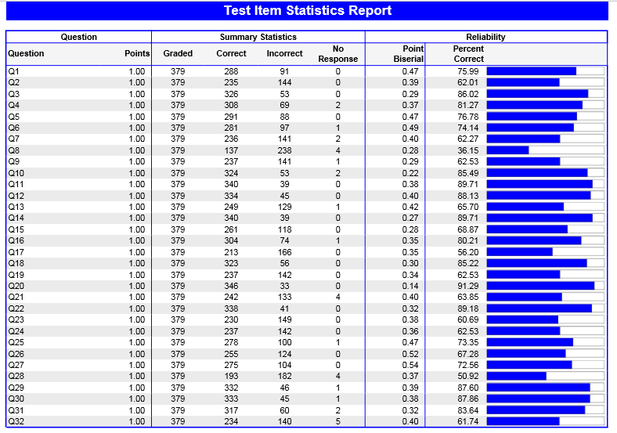

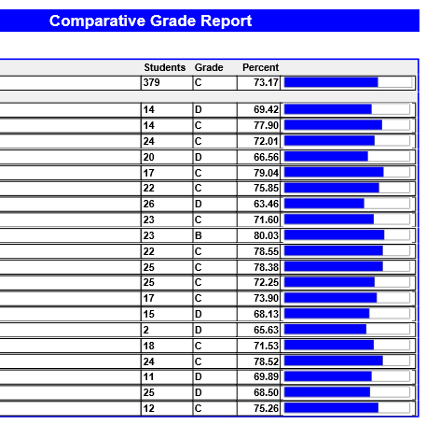

Summary:
There was an increase in the overall percent from Spring 2016 (66.33%) to Fall 2016 (73.17%). Number 28 was not the lowest, but the second lowest scoring problem. However, the percentage correct increased from 28.87% in Spring 2016 to 50.92% in Fall 2106.

