CUL205 French Cuisine
Student Text Book Survey: Pre and Post Assessment Results
Instructor: Chef Hill

The overall results show students are doing well with this advanced textbook at the Community College level.
During the Fall 2016 semester the survey questions were open ended. To better analyze the data I added a Likert scale for each question (strongly agree to strongly disagree) during the Spring 2017 administration. The chart below provides the average score by question based on the pre and post survey assessment.
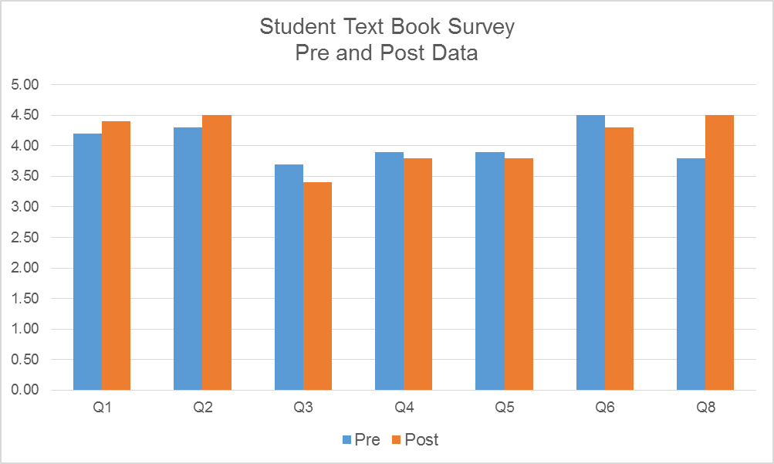
Student pre assessments were very positive and rankings were high for most questions. Students in both pre and post assessments were very satisfied with the cost and affordability of the book.
Post assessments were higher for Q1, Q2, Q8 than the pre assessments. These questions addressed cost, size and appropriate text.
Questions 3-6 addressed students feelings regarding the depth and their confidence in the use of the text.
Question 7 asks if the student plans to keep or sell back the book, all students both pre and post said they would keep the book.
Question 8 asks, “Do you feel Is this is an appropriate text book for this class CUL205 French Cuisine?” Overall, students strongly agreed that the book was a useful textbook for the course.
From this CATS project I have made the following adjustments;
I revised my class instruction and required students to reference the contents of the text “Le Repertoire de la Cuisine” when writing a menu. Student must reference the text a minimum of 6 times. This adjustment to their menu assignments made students more familiar with the content and arrangement of material and information within the book.
Another observation of mine is this class is a capstone class for the culinary associate’s degree. Students take this class in their final semester, and they have grown their skills and knowledge to better adapt to the complexity of the textbook.
Since gathering the results from this survey I now make it a point to explain the history of this textbook “Le Repertoire de la Cuisine” and this seems to have a profound result of student appreciation of the text.
Due to the positive results of this survey I will continue to incorporate this book in my teaching of the French cooking class. As a supplement to this textbook, I may decide to add another classic cookbook with recipes, color illustrations and procedures. This text is “Larousse Gastronomique” by author Prosper Montagne’. Incidentally both “Le Repertoire de la Cuisine” and “Larousse Gastronomique” are timeless and were my required text books decades ago in my 4 year culinary apprenticeship at the renowned “Greenbrier Resort Culinary Academy “ apprenticeship in White Sulphur Springs W. Va.
http://www.greenbrier.com/Dining/Culinary-Apprenticeship

