**Chemistry 130AA Concept Inventory**

1. A 1.0-gram sample of solid iodine is placed in a tube and the tube is sealed after all of the air is removed. The tube and the solid iodine together weigh 27.0 grams.



The tube is then heated until all of the iodine evaporates, filling the tube with iodine gas. After heating, the total weight will be:

1. less than 26.0 grams.
2. 26.0 grams.
3. 27.0 grams.
4. 28.0 grams.
5. more than 28.0 grams.
6. What is the reason for your answer to question 1?
7. A gas weighs less than a solid.
8. Mass is conserved.
9. Iodine gas is less dense than solid iodine.
10. Gases rise.
11. Iodine gas is lighter than air.
12. Iron combines with oxygen and water from the air to form rust, iron oxide. If an iron nail were placed in a beaker and allowed to rust for a month, one should find that the rusty nail weighs:
13. less than the original nail.
14. the same as the original nail.
15. more than the original nail.
16. It is impossible to predict.
17. What is the reason for your answer to question 3?
18. Rusting makes the nail lighter.
19. Rust contains iron and oxygen.
20. The nail flakes away.
21. The iron from the nail is destroyed.
22. The flaky rust weighs less than iron.
23. You have a block of aluminum. If you cut the block in half how does the density of the new block compare to the original block?
    1. The density increases.
    2. The density decreases.
    3. The density remains the same.
24. What is the reason for your answer to question 5?
    1. Each cubic centimeter of aluminum still has the same mass.
    2. Reducing the mass of the sample reduces the density.
    3. Reducing the volume of the sample increases the density.
    4. None of these accounts for what happens to the density.
25. Figure 1 represents 1.0 L of a solution of sugar dissolved in water. The dots in the magnification circle represent the sugar molecules. In order to simplify the diagram, the water molecules have not been shown.

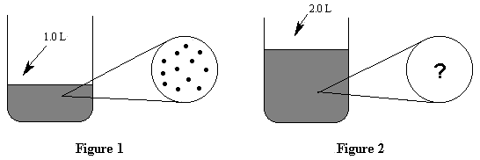  
Figure 1

Which of the following represents the view after 1.0 L of water was added to the beaker? (Figure 2).

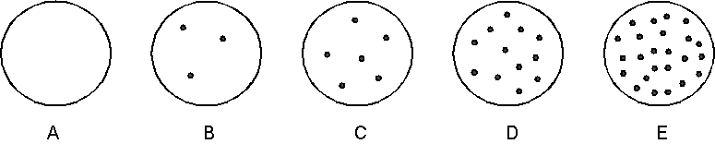  
Figure 2

1. 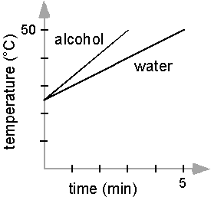Equal quantities of water and alcohol ar room temperature are heated at the same rate under identical conditions to 50°C. The water takes 2 minutes longer to reach the final temperature. Which liquid received more energy as it warmed to 50°C?
2. The water.
3. The alcohol.
4. Both received the same amount of energy.
5. It is impossible to tell from the information given.
6. What is the reason for your answer to question 8?
7. Water has a higher boiling point than the alcohol.
8. Water requires more energy to have the same temperature change as alcohol.
9. Both liquids had the same temperature change.
10. Alcohol has a lower density and vapor pressure than water.

*Questions 10-11* refer to the graph below. It is the graph of a solid as it is heated.

Time

Temperature

X

Z

Y

1. Which of the following diagrams represents what is going on at section Y?

A

B

C

D

E

1. Which statement explains the shape of the graph at section Y?
   1. The temperature is slowly increasing because of the phase change.
   2. The temperature is slowly increasing because there is no phase change.
   3. The temperature is constant because of the phase change.
   4. The temperature is constant because there is no phase change.
2. Energy is released when hydrogen burns in air according to the equation

2 H2 + O2 -- 2 H2O

Which of the following is responsible for the release of energy?

1. Breaking hydrogen bonds.
2. Breaking oxygen bonds.
3. Forming hydrogen-oxygen bonds.
4. Both (a) and (b) are responsible.



1. Which of the following Lewis dot structures is plausible?

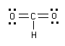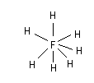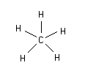

1. Consider the Lewis Dot Structure for OF2.



What is the angle between the two O-F bonds?

1. 90°
2. 109.5°
3. 120°
4. 180°
5. 270°
6. Which of the following about pH is false?
7. As pH decreases, [H+] decreases
8. As pH decreases, [H+] increases
9. The pH of acidic solutions is less than 7
10. pH is the opposite of the log of [H+]
11. Why is water classified as neutral on the pH scale?
12. Water contains no H+ or OH- ions.
13. Water contains equal amounts of H+ and OH- ions.
14. Water contains more H+ than OH- ions.
15. Water contains more OH- than H+ ions.
16. The diagram represents a mixture of S atoms and O2 molecules in a closed container.



Which diagram shows the results after the mixture reacts as completely as possible according to the equation:

2 S + 3 O2 -- 2 SO3



1. Pick the particle diagram that best represents 2 N2O4.

**A**

B

C

D

E

1. A small block of solid aluminum is taken out of the freezer and heated at a constant rate to room temperature Choose the graph which best describes the change in the average temperature of the aluminum (T) as time passes (t), neglecting any heat loss to the environment:

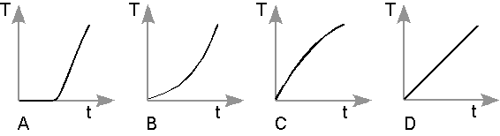

1. The temperature stays constant for a while, then rises (A)
2. The temperature rises more slowly at first, then faster (B)
3. The temperature rises more rapidly at first, then slower (C)
4. The temperature rises at a constant rate (D)
5. Which one of the following statements best explains your prediction in the question above?
6. It is hard to warm up something cold; it becomes easier to heat as it warms up.
7. Very cold things absorb heat more quickly.
8. At first, the energy supplied goes into overcoming attractive forces in the solid.
9. The heat output increases the thermal energy of the system at a constant rate.
10. The motion of the aluminum particles in the solid is restricted.

1. A sample of liquid ammonia (NH­3) is completely evaporated (changed to a gas) in a closed container as shown:

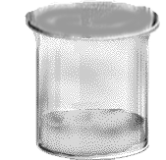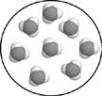 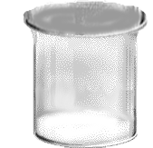

**NH3(l)**

**vacuum**

Which of the following diagrams best represents what you would “see” in the same area of the magnified view of the vapor?

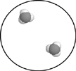 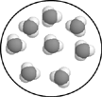 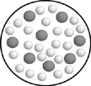 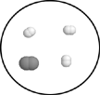 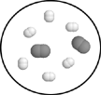

A. B. C. D. E.

1. Which of the following must be the same before and after a chemical reaction?
2. The sum of the masses of all substances involved.
3. The number of molecules of all substances involved.
4. The number of atoms of all substances involved.
5. Both (a) and (c) must be the same.
6. Each of the answers (a), (b), and (c) must be the same.

You spray a strong perfume in the center of a sealed (airtight) room.



A B C D E

1. Which of the diagrams above represents how the perfume particles are spaced (distributed) a few seconds after you sprayed the perfume?

A) A B) B C) C D) D E) E

1. Which of the diagrams above represents how the perfume particles are spaced (distributed) several minutes after you sprayed the perfume?

A) A B) B C) C D) D E) E