Estrella Mountain
Community
College

DRS SEMESTER REPORT
SPRING 18

ACCOMMODATIONS
# of requests for accommodations | 413

OUR INTERACTIONS
# of students coaching sessions | 37
# of interactions with faculty | 70
186 meetings with 160 students

OUR MOST FREQUENT ACCOMMODATION - TESTING
Number of testing accommodations | 398

MODIFIED ATTENDANCE
12 students | 36 classes

TITLE IX - PREGNANT AND PARENTING STUDENTS
12 students

ACTIVE STUDENTS (MAY NOT NEED ACCOMMODATIONS)
179 students
ACTIVE NUMBER OF STUDENTS
REQUESTING ACCCOMODATIONS
131 students

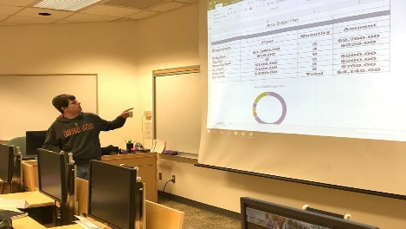
OUR COMMUNITY
PARTNERSHIP WITH ONE STEP BEYOND
COMMUNITY EDUCATION
Intro to Windows/
Microsoft Office
Semester | # of starts | # of completes
Fall 17 | 11 | 11
Spring 18 | 15 | 14

COLLEGE CREDIT
ENG091
Semester | # of starts | # of completes
Spring 18 | 3 | 3
3 hours of tutoring weekly by DRS staff

FALL 18
COMMUNITY EDUCATION
Intro to Windows/Microsoft Office
Technology Safety
COLLEGE CREDIT
ENG091
CIS105

