Mini Case Study Muscle Tissue
A 35-year-old male is visiting his primary physician. He complains of drooping of his right eyelid (ptosis) and double vision in the affected eye. The patient also complained of gradually developing difficulty in swallowing and chewing.
Upon assessment, the physician noted the inability to close the affected eye and the patient could not sustain direct eye contact (gaze). He also shows an inability to smile. The patient felt weakness at the shoulder joint after holding up his arms for a few minutes (weakness is evident with exertion).
Q. Based upon your understanding of Neuromuscular Junction, abnormality of which structure could be the potential cause for his signs and symptoms.
a. Motor Neuron b. Neurotransmitter and its receptor c. Ion levels
d. Muscle Fibers e. Any of the above can be a potential cause

An in-office Blood Work is ordered (Test 1) the following results are received, ask your instructor for test results. (See results on Page 3)
Q. Does the Blood Work help you to identify the cause? YES/NO – Explain the reason for your answer.

Another test is performed in the office, keeping in view the patient’s history and blood test results.
The patient is given an injection of (Tensilon) Edrophonium, an acetylcholinesterase inhibitor.
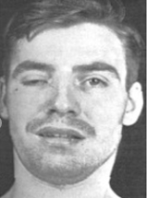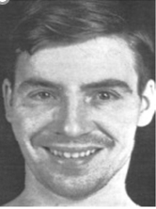
Before Tensilon Test After Tensilon Test
Q. Does the injection show improvement? Yes / No

Q. The enzyme Acetylcholinesterase degrades which chemical?
Q. How will Edrophonium (Acetylcholinesterase inhibitor) affect the level of Acetylcholine at the neuromuscular junction?

To confirm the diagnosis, the physician ordered two additional tests:
1. Blood level of Acetylcholine Receptor Antibodies (AchR antibodies)
2. Electromyography (EMG) to analyze his muscle strength and muscle action potential by Repetitive Nerve Stimulation (RNS), which is part of EMG. (shown below)

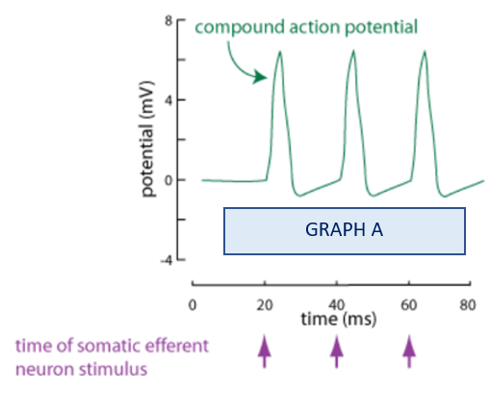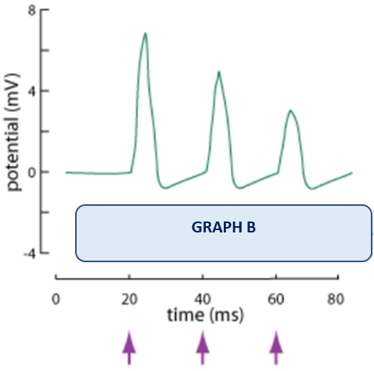
Q. Which Action Potential Graph A or Graph B represents the patient and why?

Ask your instructor for the AchR antibodies test (Test # 2 see page # 4) result. Is it Positive or Negative?

Q. Now, based upon your understanding of the Neuromuscular Junction (NMJ) and the test results, can you identify the structure that is responsible for the patient’s problems.

In-office blood work (Test 1)
Blood Test | Test Result | Normal Range
Erythrocyte count | 5.0 | 4.32 --- 5.72 million cells/ mcL
Leukocyte count | 8,000 | 3500 – 10,500 cells/mcL
Hemoglobin | 15 | 13-17 g/dL (men)
Sodium | 140 | 135 – 145 mmol/ L
Chloride | 100 | 95 – 105 mmol/L
Potassium | 4 | 3.5 – 5 mmol/L
Calcium | 9 | 8.5 – 10.5 mg/dL
Glucose | 100 | 65 – 110 mg/dL

Acetylcholine Receptor Antibodies level (Test 2)
Blood Test AchR antibodies | Test Result | Normal Range
Acetylcholine Receptor Antibodies level | 1.2 nmol/L | 0.0 – 0.4 nmol/L

