Completion Rates of CHM151 students 2018 - 2025
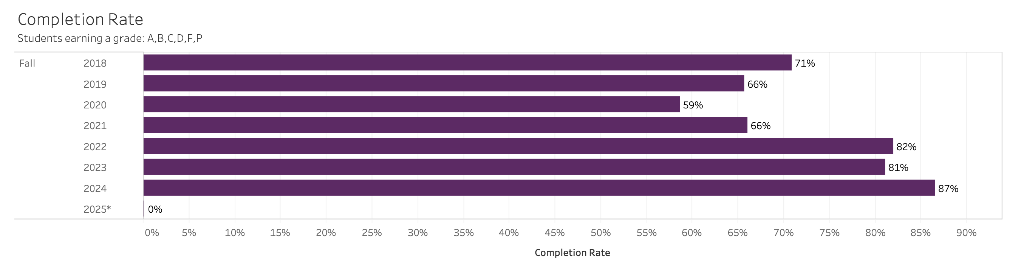
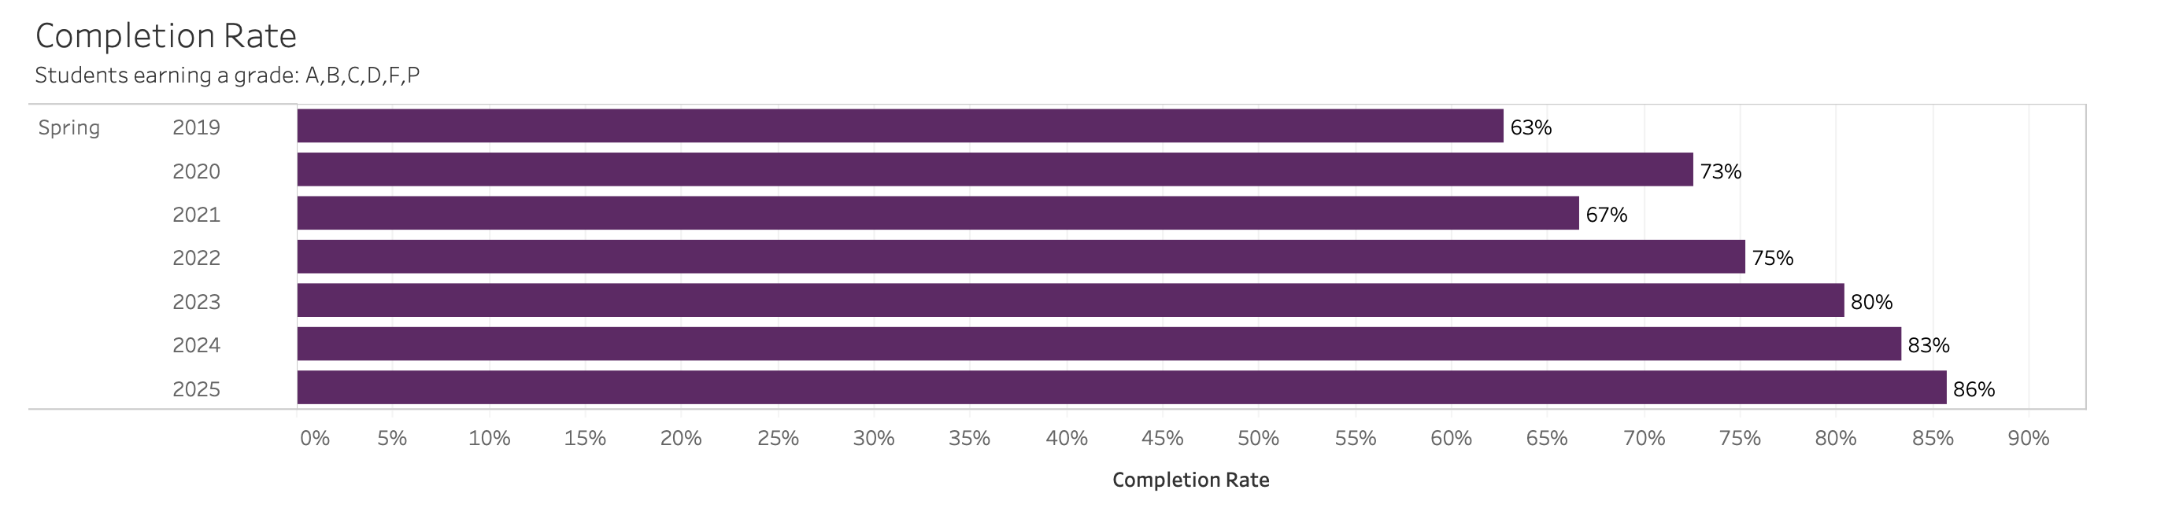
Success Rates of CHM151 students 2018 - 2025
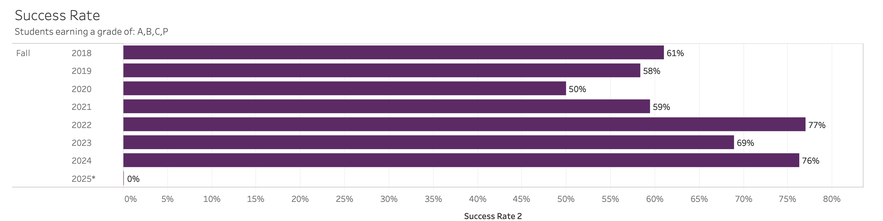
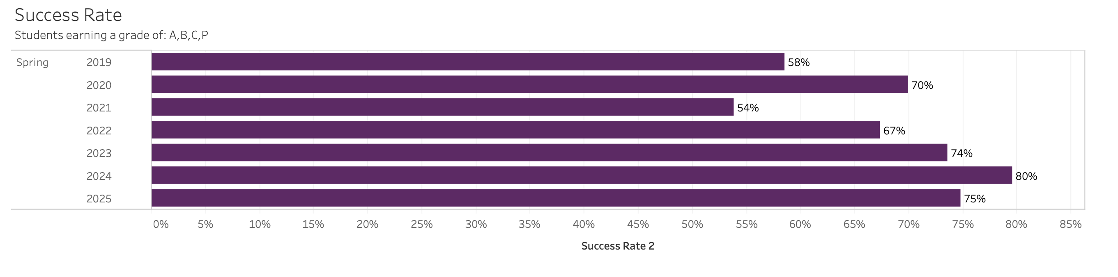

Withdrawal Rates of CHM151 students 2018 - 2025
