Appendix C Likert Scale pre- and post- survey results

Pre Assessmentsurvey results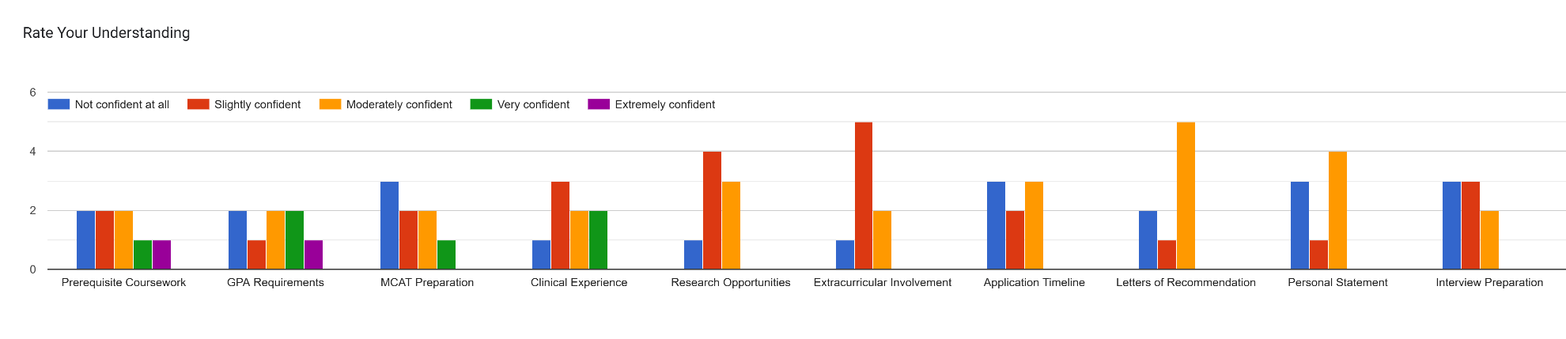
Post Assessment survey results