Appendix A Pre- Assessment Survey Results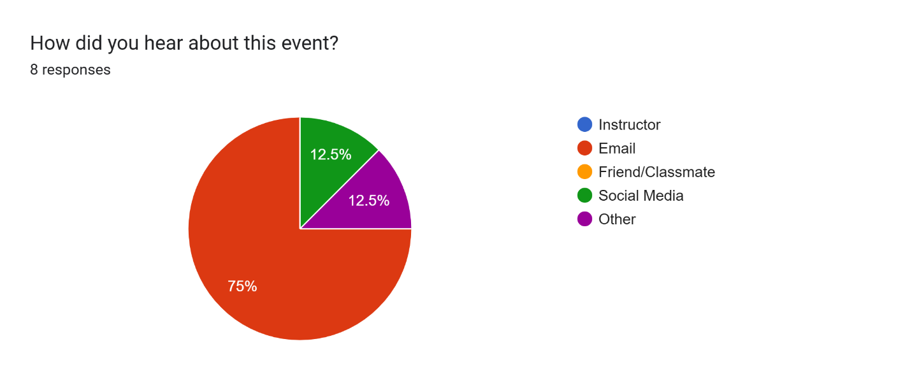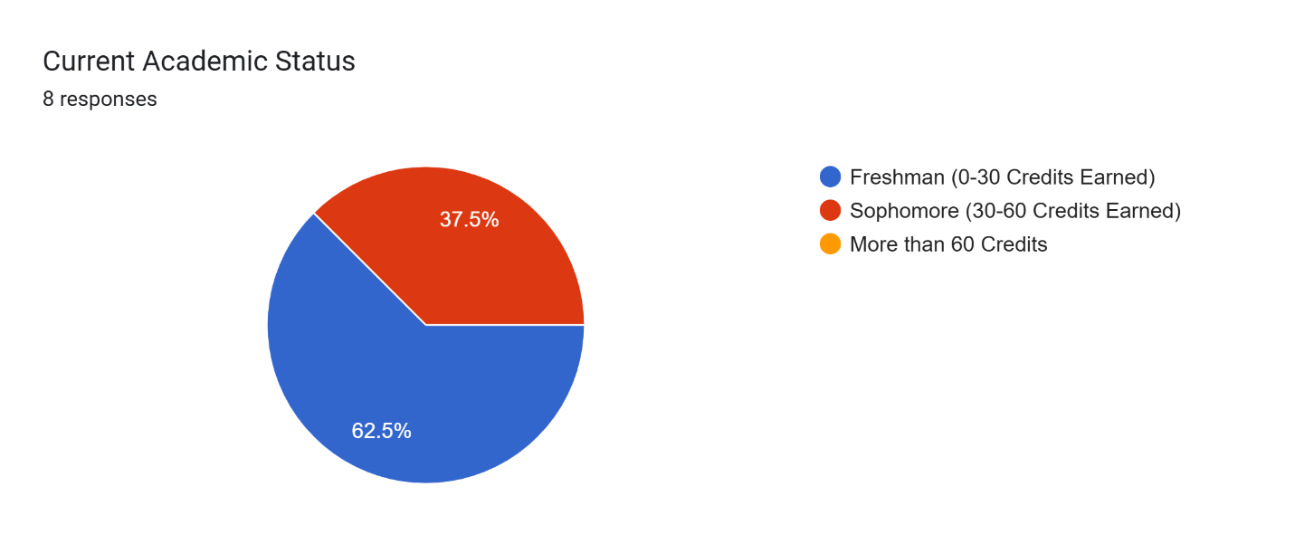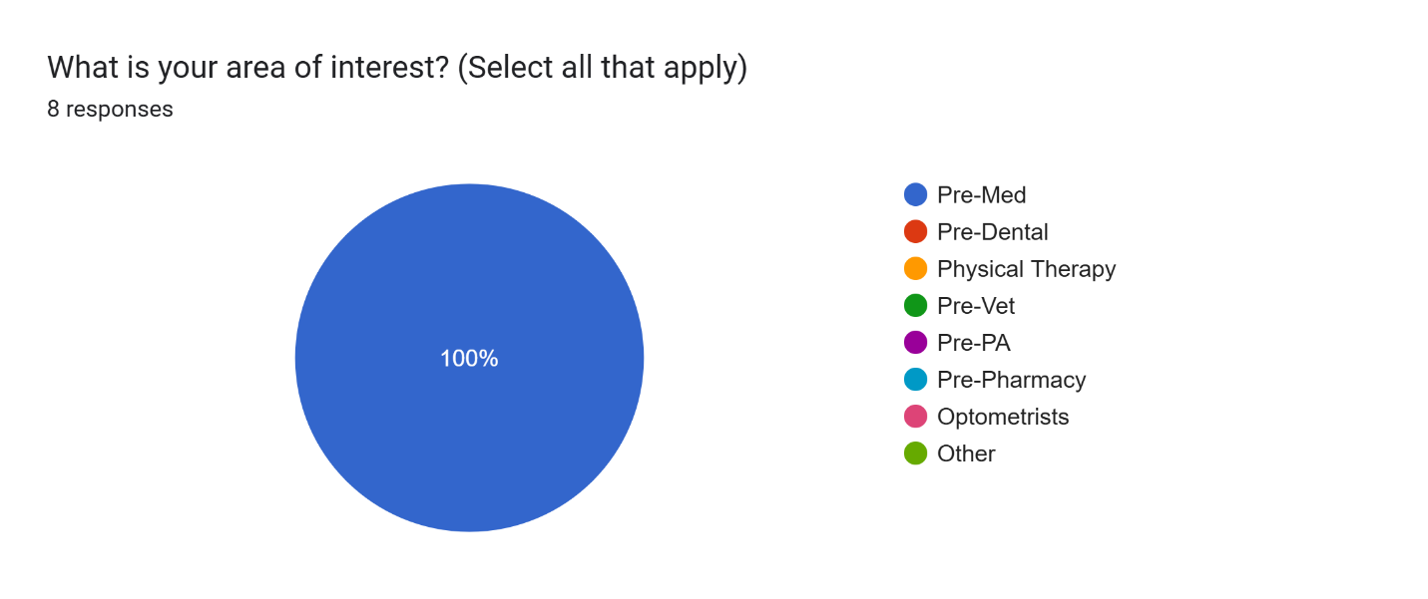

Knowledge and Understanding
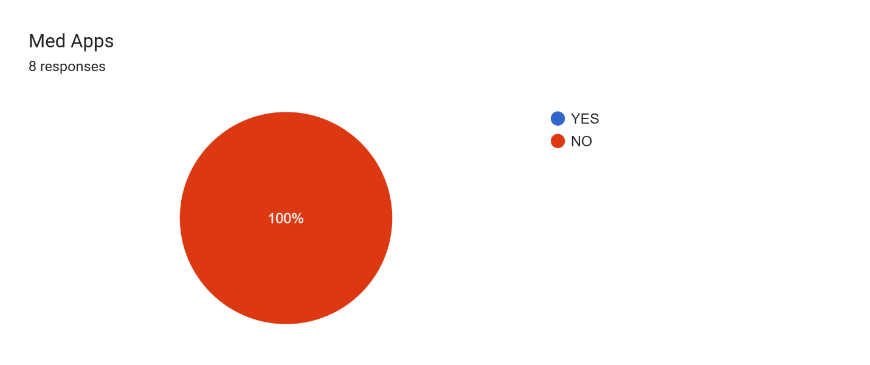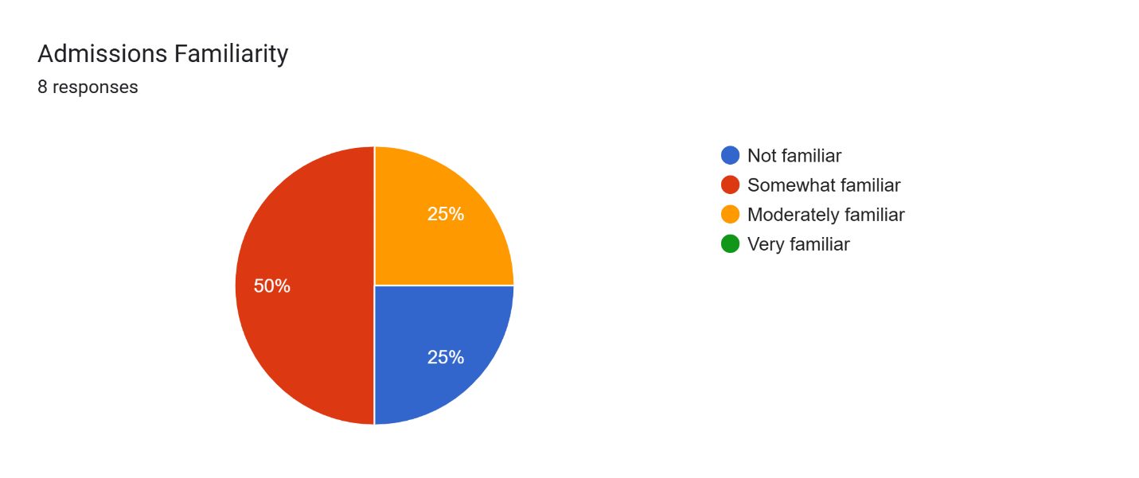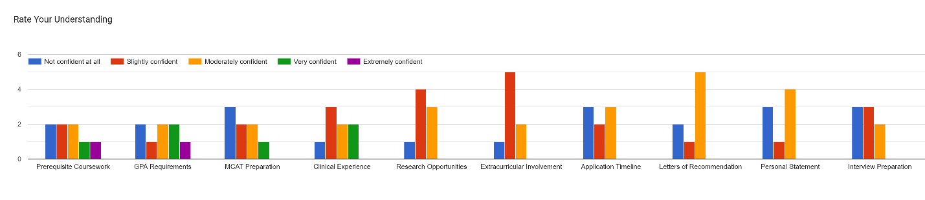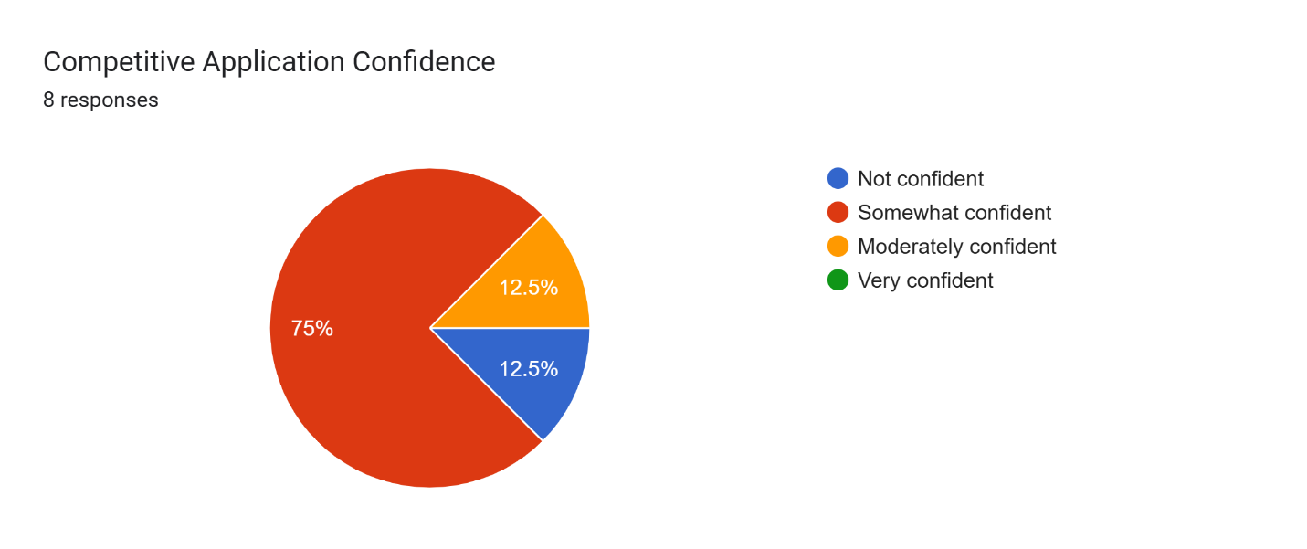

What is your biggest concern?
The MCAT and personal statements
Having a great mcat score

high volume of applicants vs low acceptance

Costs and pathway being a first generation student
t
My biggest concern would be getting myself out there and having more hands on experience within the medical field.

My biggest concern id my fear of failure, not having a GPA that’s high enough. I’m a first generation college student, so being a pre-med is intimidating.

My biggest concern would be in finding a MD or DO in order to shadow before applying for medical school. Another concern would be finding research opportunities.

