The world gone to SCALE
Art 112
Collage Exercise
5pt
Due End of Class

Scale: is the dimensional element defined by other elements of design size relative to art, its surroundings, or in relation to humans. Scale is the size of an element as it relates to its usual physical size.

For this in class exercise create one 8x10 collage that explores extreme shifts in scale. I’d like you to create a world where the normal sense of scale has been altered – things that are normally large become small. Things that are normally small become large – but coexist in a pictorial space. I hope that in so doing you begin to realize what a powerful design element scale can be. Scale is normally used to create a sense of order, but altering this normative view a powerful reshaping, reimaging and questioning can occur. Feel free to use a mixed media approach to this: paint, found objects, markers, etc… can be added to the collage to help create a convincing, if ambiguous, surreal and inverted world.

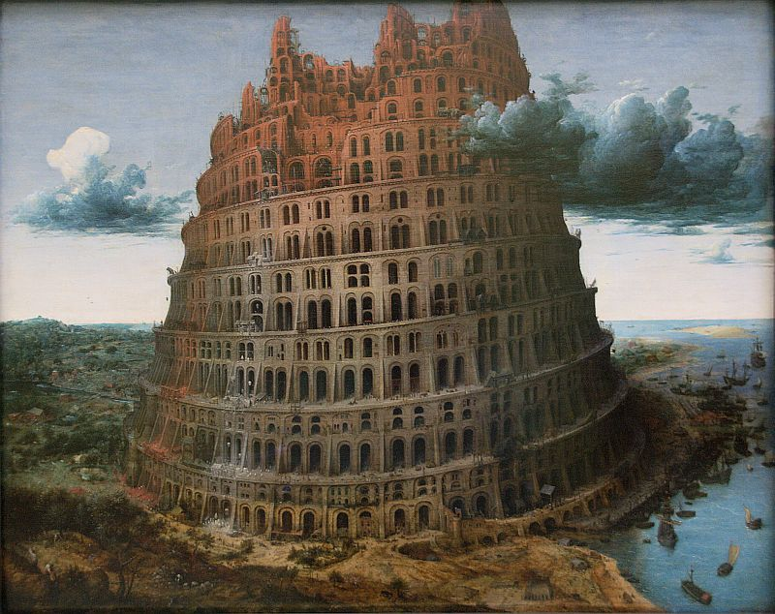
Pieter Bruegel the Elder, the Tower of Babel, 1563

