3A. Given the graph of the velocity function, what can you say about the position function? I.E. Over what intervals is the change in position in the positive direction (increasing)? Where is the change in position in the negative direction (decreasing)?

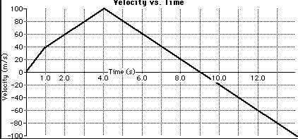

3B. Using the same graph above, what is the acceleration at t = 8 seconds?

Data and Conclusions
For years, I have tried to get students to be able to interpret a velocity time graph to help prepare them for Physics the following semester. The results in the traditional class are typical results for the last several semesters. The learning community results are a fantastic improvement. In the future, I plan to incorporate more physics into the traditional class to see if it helps the non-learning community students.

Traditional Class  A. 3/22 students got this correct  B. 11/22 students had the basic idea (I.E. They knew to find the slope).  Of the 11 students, only 2 had part B correct. The other 9 students were missing a “-“ sign or had incorrect units. | Learning Community  A. 10/18 students got this correct  B. 17/18 students had the basic idea (I.E. They knew to find the slope).  Of the 17 students, 11 had part B correct. The other 6 had a “-“ sign missing or incorrect units.

